# **DECLARATION**

**Student’s Declaration**

I hereby declare that the information contained in the project report is the results of my own effort and due citation have been made. I further declare that it contains no material previously published by another person nor material which have been accepted for the award of any other degree or diploma in the university, nor elsewhere except where due acknowledgement has been made.

STUDENT

SIGNATURE

DATE

BOATENG, PRINCE MPEM

…………………………………….

……………………………………

**Supervisor’s Declaration**

I declare that the project report is the results of the project work of Student I supervised during the 2023/2024 Academic year.

SUPERVISOR

SIGNATURE

DATE

EMMANUEL OPPONG AFRIYIE

………………..……………………..

…………………………………………

**Head of Department’s Declaration**

I declare that this project report submitted to me duly signed by the student and the project Supervisor in accordance with the requirements of Kumasi Technical University.

NANE OF HEAD OF DEPARTMENT

SIGNATURE

DATE

DR. OBENG YAW ASARE

………………..……………………..

………………..…………………….

# **PROJECT MARKING SHEET**

Index Number of Student: …………………………………………………………………..

Title of Project: E-VOTING SYSTEM WITH ONLINE UPLOAD OF RESULTS

Name of Mark: ………………………………….....................................................................

Total Mark Awarded (%): ……………………...…….. Signed: ………………………

Signature of HOD: ……………………………………… Date: …………………….......

SPECIFIC ASSESSMENT FEATURES

|  |  |  |  |
| --- | --- | --- | --- |
| **Criteria** | **Description** | **Maximum Mark** | **Mark Awarded** |
| Content (70%) | Review of Related Work | 10 |  |
| Understanding the subject area | 10 |  |
| Clarity and depth of project description | 10 |  |
| The complexity of the problem | 10 |  |
| Quality of the software (or device), design, and style | 10 |  |
| Appropriate use of data structures, algorithms, or design principles | 10 |  |
| Appropriate use of tools, libraries, existing code, etc. | 10 |  |
| Organization and Structure of the report (20%) | Balance of detail | 5 |  |
| Logically developed structure | 5 |  |
| Correct citation of sources | 5 |  |
| Lay out Sections and subsections | 5 |  |
| Style and  Presentation (10%) | Style of Writing, Grammar | 5 |  |
| Length (At least 5000 words) | 5 |  |
| Total |  | 100 |  |

# **ACKNOWNLEGDEMENT**

I would like to express my sincere gratitude and appreciation to all those who have contributed to the successful completion of my final year project.

First and foremost, I am deeply indebted to my project supervisor, **Emmanuel Oppong Afriyie**, for his guidance, support, and invaluable feedback throughout the entire duration of the project. Their expertise and willingness to share their knowledge have been instrumental in shaping the direction and quality of my work.

I would also like to extend my thanks to the faculty and staff of Computer Science Department, who provided the necessary resources and facilities for carrying out this project. Their commitment to fostering a conducive learning environment has greatly contributed to my academic growth.

Furthermore, I am grateful to my friends and classmates who provided me with moral support, encouragement, and valuable insights during the course of this project. Their discussions and brainstorming sessions helped me refine my ideas and overcome challenges along the way.

In addition, I would like to acknowledge the participants who took part in any surveys, interviews, or experiments conducted as part of this project. Their contribution and willingness to share their experiences were crucial in gathering relevant data and insights.

Last but not least, I would like to express my heartfelt appreciation to my family for their unwavering love, support, and understanding throughout my academic journey. Their encouragement and belief in my abilities have been the driving force behind my accomplishments.

In conclusion, I am truly grateful to everyone who has played a part, big or small, in the completion of this final year project. Your contributions have been invaluable, and I am thankful for the knowledge, experiences, and personal growth that this project has brought me.

# **DEDICATION**

This final year project is dedicated to Individual, whose unwavering support and encouragement have been instrumental in my academic journey.

To my Dad Mr. Samuel Kofi Boateng and my mom Mrs Adriana Boateng, whose love and belief in me have been a constant source of inspiration, this project is dedicated to you. Your unwavering support, sacrifices, and understanding have been the foundation of my success, and I am forever grateful for your presence in my life.

I would also like to dedicate this project to my supervisor, **Emmanuel Oppong Afriyie**, whose guidance, expertise, and commitment to my academic development have shaped me into the person I am today. Your mentorship and encouragement have pushed me beyond my limits and instilled in me a passion for learning and growth.

Furthermore, I would like to dedicate this project to my friends and classmates, who have been by my side throughout this journey. Your camaraderie, support, and shared experiences have made this academic endeavour memorable and enjoyable.

Lastly, I extend my heartfelt dedication to all the individuals who have contributed to this project in any way, including participants, collaborators, and research subjects. Your willingness to contribute and share your expertise, experiences, and time have been invaluable to the success of this project.

This final year project is a testament to the collective efforts and support of all those mentioned above, and I am honoured to dedicate it to each and every one of you.

# **ABSTRACT**

This project aims to develop an E-voting system with the capability of online result upload specifically designed for Kumasi Technical University (KsTU). The primary objectives of the system are twofold: first, to streamline the registration of eligible voters by offering two options, bulk registration through CSV file uploads or individual data entry, thereby ensuring a user-friendly and efficient registration process; second, to enhance the integrity of the voting process by implementing a robust identity verification mechanism. This authentication will rely on OTPs (One-Time Passwords) sent via SMS, thereby bolstering the security and accuracy of voter verification. Additionally, the system will enable voters to cast their ballots securely and privately in a one-to-one voting setup. Once the voting period concludes, it will accurately aggregate the votes and make them available for public viewing through online result upload. Furthermore, the project will empower Electoral administrators (EC) to set and manage a valid voting period, ensuring the entire process adheres to predefined timeframes. Anticipated outcomes include increased accessibility and convenience for voters, heightened election security, greater transparency in the voting process, and the timely availability of election results through online result upload.

**TABLE OF CONTENTS**

DECLARATION i

PROJECT MARKING SHEET ii

ACKNOWNLEGDEMENT iii

DEDICATION iv

ABSTRACT v

LIST OF FIGURES ix

LIST OF TABLES xi

CHAPTER ONE 1

INTRODUCTION 1

1.1 Background 1

1.2 Statement of Problem 2

1.3 Aim and Objectives 2

1.3.1 Specific Objectives 2

1.4 Scope of the Study 3

1.5 Significance of the study 3

CHAPTER TWO 5

2.1 LITERATURE ON VOTING 5

2.1.1 History of Voting 5

2.1.2 Rules and regulations of Voting 5

2.1.3 Changes in Voting practices 5

2.1.4 Impact of e-voting on voting 6

2.2 REVIEW ON VOTING SYSTEM 7

2.2.1 Review on OpaVote Voting System 7

2.2.2 Review on ElectionBuddy Voting System 8

2.2.3 Review on Follow My Vote Voting System 9

2.2.4 Review on E-Voting System with Online Upload Of Results 9

2.3 SUMMARY ON PROPOSED SYSTEM 10

CHAPTER THREE 11

THE PROPOSED SYSTEM DESIGN 11

3.1 The System Methodology to be used 11

3.1.1 Reasons for Incremental Model 11

3.2 Incremental Model 11

3.3 System Design 22

3.3.1. Use Case Analysis 22

3.3.2 Use Case Diagram 23

3.3.3 Flowchart Diagram 24

3.3.4 System Architecture Diagram 25

3.3.5 Entity Relationship Diagram 26

3.3.6 Data Flow Diagram 27

3.3.6 Image type that is Support 28

CHAPTER FOUR 30

SYSTEM IMPLEMENTATATION AND DESIGN 30

4.1 Class Diagram 30

4.2 Sequence Diagram 32

4.3 System Interface 33

4.3.1 Homepage 33

4.3.2 Voter Login Interface 35

4.3.3 Electoral Commissioner 38

4.3.4 Polling Officer 51

4.4 Software Testing 56

4.4.1 Error Message of the System 60

CHAPTER FIVE 67

SUMMARY, CONCLUSION AND FUTURE WORK 67

5.1 Summary of Work 67

5.2 Discussion 68

5.4 Analysis of the Implemented System 69

5.4.1 Strength and Limitation 69

5.3 Conclusion 70

5.4 Future Work 70

REFERENCES 71

# **LIST OF FIGURES**

Figure 1 Increment Model Diagram 12

Figure 2 Usecase Diagram for the System 24

Figure 3 Flowchart Diagram for the System 25

Figure 4 System Architecture diagram for the System 26

Figure 5 Entity Relationship Diagram for the System 27

Figure 6 Data flow diagram for the system 28

Figure 7 Class Diagram for the System 31

Figure 8 Sequence Diagram for the System 32

Figure 9 Homepage Interface 33

Figure 10 Contact Us Interface 34

Figure 11 About Us Interface 34

Figure 12 Voter Login for Casting Vote 35

Figure 13 Voter Voting Interface 36

Figure 14 Voter Login for Viewing Results 36

Figure 15 Election Result Interface for Voters 37

Figure 16 Forgot Serial Code for Voters 38

Figure 17 EC Login Interface 39

Figure 18 EC Dashboard 39

Figure 19 Registering New EC Account Interface 40

Figure 20 Voter Registration Interface 41

Figure 21 Candidate Registration Interface 42

Figure 22 EC View Election Results Interface 43

Figure 23 Election Settings Interface 44

Figure 24 Portfolio Registration Interface 45

Figure 25 Department Registration Interface 45

Figure 26 Voter Management Interface 47

Figure 27 Candidate Management Interface 48

Figure 28 Polling Agent Management Interface 49

Figure 29 EC Profile Settings Interface 49

Figure 30 EC Activity Logs Interface 50

Figure 31 EC Help Interface 51

Figure 32 Polling Agent Login Interface 51

Figure 33 Polling Agent Dashboard Interface 52

Figure 34 Voter Verification Interface 53

Figure 35 Candidate Verification Interface 53

Figure 36 Polling Agent Monitor Election interface 54

Figure 37 Polling Agent Audit Election Interface 55

Figure 38 Polling Agent Issue Report with Chat Room Interface 56

Figure 39 Login Error Message 60

Figure 40 EC Registration Error Message 61

Figure 41 Voter Registration Error Message 61

Figure 42 Candidate Registration Error Message 62

Figure 43 Portfolio Registration Error Message 63

Figure 44 Department Registration Error Message 63

Figure 45 SMS Error Message 64

Figure 46 Password Does Not Match Error Message 64

Figure 47 Polling Agent Registration Error Message 65

Figure 48 Voting Error Message 65

Figure 49 Required Field Error 66

# **LIST OF TABLES**

Table 1.1 Test Case for Electoral Commissioner 58

Table 1.2 Test Case for Voters 59

# **CHAPTER ONE**

# **INTRODUCTION**

## **1.1 Background**

The background of the study on an E-voting system with online upload of results lies in the increasing need for efficient and transparent electoral processes [1]. Traditional paper-based voting systems often suffer from various challenges such as long queues, logistical issues, manual counting errors, and the potential for fraud or manipulation.

In response to these challenges, electronic voting (E-voting) systems have been developed to streamline the voting process, enhance accuracy, and improve transparency [2]. These systems utilize electronic devices and software to facilitate the casting and counting of votes.

One important aspect of an E-voting system is the online upload of results [3]. This feature enables the real-time transmission and display of voting results, providing instant visibility to the general public. By allowing results to be uploaded and accessible online, the system can offer increased transparency and accountability.

The motivation behind studying E-voting systems with online result uploads is to address concerns related to election integrity, efficiency, and trust [4]. The ability to upload and display results online helps minimize the time required for result tabulation and enables a faster announcement of the outcomes. Additionally, it allows for independent verification by various stakeholders, including observers, and voters.

However, implementing an E-voting system with online result uploads also brings forth several challenges that need to be addressed. These challenges include ensuring the security of the electronic infrastructure, protecting against hacking or tampering attempts, maintaining voter privacy and anonymity, and establishing robust authentication mechanisms to prevent unauthorized access to the system.

## **1.2 Statement of Problem**

The statement of problem related to an e-voting system with online upload of results could be as follows:

The current manual voting system lacks efficiency, transparency, and accessibility, leading to challenges in accurately recording, counting, and disseminating election results. There is a need for an e-voting system with online upload of results to address these issues and provide a secure, efficient, and transparent platform for voters to cast their votes electronically and ensure swift, accurate, and widely accessible publication of election results."

In this statement, the problems highlighted include the inefficiency and lack of transparency in the manual voting system, difficulties in accurately recording and counting votes, and challenges in timely and accessible result dissemination. The proposed solution is the implementation of an e-voting system with online result upload to overcome these problems and improve the voting process.

## **1.3 Aim and Objectives**

The aim and objective of this project is to facilitate efficient and transparent voting processes. It allows voters to cast their votes electronically, eliminating the need for physical ballot papers and manual vote counting. The system securely captures and records votes, ensuring accuracy and integrity. The online upload of results enables real-time reporting and provides immediate access to the election outcomes.

### **1.3.1 Specific Objectives**

The main objectives of an e-voting with online upload of result are:

* To register eligible voters using CSV file or individual entry.
* To authenticate voters' identities using OTPs, which are delivered via SMS.
* To enable voters to cast one to one votes.
* To cumulate vote casted and make available after voting time.
* To set valid voting period.

## **1.4 Scope of the Study**

**Project Scope: E-Voting System with Online Upload of Results**

The project aims to design, develop, and implement a secure and user-friendly e-voting system. The system will enable eligible voters to cast their votes electronically and allow election administrators (EC) to manage the election process efficiently. The key features and functionalities of the project scope include voter registration, authentication and security measures, electronic ballot creation, real-time vote casting, online result management, result verification, and an audit trail for transparency. The system will have distinct user roles, including Electoral Commissioner, Polling Officer and voters. Constraints include a specific budget and timeline, assuming sufficient internet connectivity for online activities.

**Product Scope: E-Voting System with Online Upload of Results:**

The e-voting system will include a comprehensive set of features, such as a voter registration module for eligible voters, secure authentication mechanisms, electronic ballot creation for various elections, real-time vote casting, and a dashboard for election administrators (EC) to monitor voting progress, and a secure platform for online result upload. The system will provide mechanisms for result verification by relevant stakeholders and maintain an audit trail for transparency and auditing purposes. Usability and accessibility will be prioritized to ensure that the system is user-friendly for voters of all backgrounds and abilities. The system will be designed for scalability to handle a large number of concurrent users during peak voting periods and will be compatible with popular web browsers and accessible from desktop and mobile devices.

## **1.5 Significance of the study**

The E-voting system with online upload of results holds several significant benefits and impacts. Here are some key significances:

* **Timely and Efficient Results:** Online upload of results enables the quick and efficient reporting of election outcomes. The traditional manual counting and compilation processes can be time-consuming and prone to errors. With online upload, election officials can instantly transmit and publish results, providing real-time updates to stakeholders and the public.
* **Rapid Dissemination of Information:** Online upload of results facilitates the rapid dissemination of election information. Media outlets, researchers, and analysts can quickly access and analyse the results, enabling them to provide timely insights and reporting to the public. This speed in information dissemination contributes to informed decision-making and public discourse.
* **Minimize Cost and Resource Savings:** Implementing an e-voting system with online result upload can lead to minimum cost and resource savings for election management bodies. Traditional paper-based voting processes involve printing, distributing, and manually counting paper ballots, which can be resource-intensive. By transitioning to electronic voting and online result upload, the need for physical materials and manual labour is significantly reduced, resulting in minimum cost and resource savings.
* **Enhanced Accuracy and Reduced Errors:** Manual vote counting is susceptible to human errors, which can impact the accuracy of election results. E-voting systems with online result upload minimize the risk of errors associated with manual processes. The automated vote counting and result compilation ensure a higher level of accuracy, providing more reliable and trustworthy election outcomes.
* **Improved Post-Election Analysis:** Online result upload facilitates detailed post-election analysis and research. Researchers and data analysts can access the electronic records to study voting patterns, demographics, and other factors that influence election results. This analysis can contribute to a better understanding of the electoral process and inform future improvements in election management.

# **CHAPTER TWO**

An e-voting system with online upload of results is a digital solution that combines electronic voting with the immediate transmission of election outcomes. It allows voters to cast their ballots electronically, and the results are promptly uploaded to a central database or online platform for aggregation and analysis. This system offers advantages such as faster results, enhanced transparency, and efficient data management. However, ensuring the security and integrity of the system is crucial to maintain public trust and prevent unauthorized access or tampering.

### **2.1 LITERATURE ON VOTING**

#### **2.1.1 History of Voting**

Voting has a long and diverse history, spanning back to ancient civilizations like Greece and Rome, where direct democracy allowed citizens to participate in decision-making. During the Middle Ages, voting was less common due to monarchies and feudal systems dominating governance. The emergence of representative democracy in medieval Europe led to the election of representatives to make decisions on behalf of the people. The Age of Enlightenment in the 17th and 18th centuries gave rise to modern democratic principles, with the formation of democratic nations like the United States. In the 19th and 20th centuries, voting rights expanded to include women, minorities, and marginalized groups, thanks to suffrage movements. The 20th century witnessed technological advancements, leading to the adoption of electronic voting systems. Throughout history, voting systems faced challenges like discrimination, suppression, and fraud, prompting efforts to improve transparency and accessibility. Today, voting is an integral part of democratic societies worldwide, with various voting systems in place. Voting systems continue to evolve, with ongoing exploration of online voting and block chain-based solutions.

#### **2.1.2 Rules and regulations of Voting**

The rules and regulations surrounding voting vary across countries, but they typically include criteria such as eligibility requirements (age, citizenship), registration processes, and procedures for casting and counting votes. Rules also govern campaign financing, voter identification, and safeguards to ensure fairness and integrity in the electoral process.

#### **2.1.3 Changes in Voting practices**

Over time, voting practices have undergone significant changes. The introduction of secret ballots aimed to protect voter’s privacy and prevent coercion. Universal suffrage, granting voting rights to all citizens regardless of gender, race, or social status, has been a crucial milestone in promoting inclusivity and democratic participation. The advent of technology has further transformed voting practices, leading to the emergence of electronic voting (e-voting) systems.

#### **2.1.4 Impact of e-voting on voting**

E-voting, or electronic voting, refers to the use of digital technology to cast and count votes. It has the potential to improve the efficiency, accessibility, and accuracy of the voting process. Some of the impacts of e-voting, as discussed in the literature, include:

* **Efficiency and Cost-Effectiveness:** E-voting systems can streamline the voting process, automating tasks such as voter registration, ballot counting, and result tabulation. This efficiency can reduce costs associated with manual processes and potentially speed up the announcement of election results.
* **Improved Accuracy and Reduced Errors:** E-voting can minimize errors commonly associated with manual counting and data entry. Automated systems can help eliminate human errors, ensure accurate vote tallying, and reduce the chances of misinterpretation or tampering.
* **Security and Integrity Concerns:** The impact of e-voting also raises concerns about security and integrity. Protecting against hacking attempts, ensuring voter privacy, and safeguarding against manipulation or tampering of electronic systems are critical challenges that need to be addressed.
* **Inclusivity and Participation:** E-voting has the potential to increase voter turnout by offering more convenient online viewing of results. This can encourage participation among young voters, individuals abroad, or those who face barriers to physical polling stations.

### **2.2 REVIEW ON VOTING SYSTEM**

#### **2.2.1 Review on OpaVote Voting System**

OpaVote is an online voting platform that aims to provide secure and efficient elections and polls [6]. The system offers several key features and benefits that cater to various voting scenarios. The platform prioritizes security and confidentiality, using encryption to protect sensitive voting data during transmission and storage [7]. This focus on security ensures that voter information remains safeguarded and private.

OpaVote's user-friendly interface makes it accessible to both administrators and voters [8]. Its intuitive design simplifies the voting process, reducing the likelihood of user confusion or errors. One of the strengths of OpaVote is its support for multiple voting methods, including ranked-choice voting, approval voting, and single transferable vote (STV) [9]. This flexibility allows elections to be customized based on specific voting requirements and preferences.

Automated reminders provided by the system help improve voter participation and reduce the risk of missed deadlines [10]. These reminders serve as helpful prompts to encourage timely voting. The real-time results feature enables quick and accurate vote counting and tabulation [11]. This instant feedback enhances the transparency of the election process and allows for prompt communication of outcomes. The inclusion of a waitlist feature is beneficial for managing elections with limited capacity [12]. Voters on the waitlist can be notified if an earlier voting opportunity becomes available, ensuring maximum voter engagement.

However, like any online voting system, OpaVote faces challenges related to internet dependency [13]. Users require a stable internet connection to access the platform, which could be an obstacle in areas with limited internet accessibility. Data privacy concerns may also arise, as some individuals may be hesitant to submit personal data online, especially in elections involving sensitive or confidential information [14].

Additionally, while OpaVote is an effective online system, it may not provide offline voting options, which could be crucial in certain situations or for voters with limited internet access [15].

#### **2.2.2 Review on ElectionBuddy Voting System**

ElectionBuddy is an online voting platform designed to facilitate secure and user-friendly elections and polls [16]. The system offers several key features and benefits that cater to a diverse range of voting scenarios. The platform prioritizes security, ensuring that sensitive voting data is protected through encryption during transmission and storage [7]. This commitment to security is essential for maintaining the integrity and confidentiality of the voting process.

ElectionBuddy's user interface is highly intuitive and easy to navigate, making it accessible for both administrators and voters [8]. The straightforward design streamlines the voting process, reducing the likelihood of user confusion or errors. A notable strength of ElectionBuddy is its support for various voting methods, such as ranked-choice voting, approval voting, and preferential voting [9]. This flexibility allows for tailored elections that meet the unique requirements and preferences of different organizations and voting bodies.

The system's automated reminder feature plays a crucial role in improving voter participation and reducing the risk of missed deadlines [10]. Automated reminders prompt voters to cast their ballots, leading to higher engagement and increased voter turnout. Real-time results provided by ElectionBuddy enable prompt and accurate vote counting and tabulation [11]. The instant availability of results enhances the transparency of the election process, allowing participants to monitor outcomes in real-time.

ElectionBuddy's ballot customization feature allows administrators to create personalized and comprehensive ballots, accommodating various voting scenarios and election types [12]. This versatility ensures that the system is adaptable to the specific needs of each organization. However, like any online voting platform, ElectionBuddy faces challenges related to internet connectivity [13]. Users must have access to a stable internet connection to utilize the platform effectively.

Data privacy concerns may also arise, as some individuals may be cautious about submitting personal data online, particularly in elections involving sensitive information [14]. Overall, ElectionBuddy offers a reliable and user-friendly voting system with robust security measures and versatile voting methods [8]. Organizations seeking a platform for conducting efficient, secure, and transparent elections will find ElectionBuddy to be a valuable solution.

#### **2.2.3 Review on Follow My Vote Voting System**

Follow My Vote is an online voting platform that emphasizes secure and transparent voting. The system utilizes blockchain technology to ensure the integrity of the voting process, offering end-to-end verifiability for voters. This feature allows individuals to independently verify that their votes were accurately counted, fostering trust in the system. The platform places a strong emphasis on voter privacy, ensuring that votes remain anonymous and untraceable to individual voters. This commitment to confidentiality is crucial for maintaining the integrity of elections.

Being an open-source platform, Follow My Vote allows public scrutiny and collaborative development, which can lead to improvements in security and functionality over time. The system's accessibility is a notable advantage, enabling remote voting and reducing barriers for voters who may encounter challenges with traditional voting methods. This feature can potentially increase voter participation and engagement.

However, like any online voting system, Follow My Vote is dependent on a stable internet connection, making it less suitable in areas with limited internet access or during connectivity issues. Security concerns are always a consideration for any online system, and while blockchain technology provides a level of security, no system is entirely immune to vulnerabilities.

Furthermore, the adoption of online voting systems can face challenges due to concerns about cybersecurity, trust, and the potential for coercion in remote voting scenarios. Convincing stakeholders of the system's reliability and security is critical for wider acceptance.

#### **2.2.4 Review on E-Voting System with Online Upload Of Results**

The E-Voting system with online upload of results is an innovative approach to modernize and streamline the voting process [1]. This system aims to enhance efficiency, accuracy, and transparency in elections by leveraging electronic technology [17].

One of the key advantages of this system is its ability to facilitate remote voting [18]. By enabling voters to cast their ballots online, it offers convenience and accessibility, particularly for individuals who may face challenges. This feature can lead to increased voter turnout and broader participation in the democratic process [19].

Furthermore, the online upload of results enhances the speed and accuracy of result compilation [20]. Traditional manual counting and collation of votes can be time-consuming and prone to errors. With the E-Voting system, results are automatically generated and securely uploaded to a central database, minimizing the chances of human error and expediting the announcement of election outcomes [21].

The system also provides an additional layer of transparency and auditability. By digitally recording each vote and maintaining an electronic trail, it becomes easier to verify the accuracy of results and detect any potential irregularities or tampering [22]. This can help build trust among stakeholders and ensure the integrity of the electoral process [23].

However, it is important to acknowledge some potential concerns and challenges associated with this system. One major consideration is the need for robust cybersecurity measures to safeguard against hacking, data breaches, or manipulation attempts. Ensuring the protection of sensitive voter information and maintaining the integrity of the online platform is crucial to prevent unauthorized access or manipulation of the voting process [24].

Additionally, the implementation of an E-Voting system requires sufficient infrastructure and technological readiness. It is essential to have reliable internet connectivity and appropriate hardware and software systems in place to support the smooth functioning of the online voting platform [25]. Adequate training and education for voters and election officials are also necessary to ensure effective utilization of the system and address any technical issues that may arise.

Moreover, concerns about digital divide and inclusivity need to be taken into account. Not all individuals may have access to the necessary technology or digital literacy skills required to participate in an online voting system. Ensuring equal opportunities for all citizens to exercise their voting rights is crucial to maintaining a fair and democratic electoral process.

### **2.3 SUMMARY ON PROPOSED SYSTEM**

The proposed system is an E-voting system with online upload of results, aiming to modernize and improve the voting process. It incorporates electronic voting and an online result upload feature. The electronic voting mechanism enables eligible voters to cast their votes securely through an online platform. The system ensures privacy, integrity, and authentication of voters. After the voting period ends, authorized officials upload the results to an online platform, which enhances transparency and allows for real-time updates. The system offers benefits such as increased efficiency, accuracy, transparency, convenience, accessibility, and cost-effectiveness. However, challenges related to security, the digital divide, and gaining trust and acceptance must be considered for successful implementation.

# **CHAPTER THREE**

# **THE PROPOSED SYSTEM DESIGN**

### **3.1 The System Methodology to be used**

Several system methodologies commonly used in system design include the Waterfall Methodology, Agile Methodology, Incremental Methodology, Prototyping Methodology, Spiral Methodology, and Rational Unified Process (RUP). These methodologies offer different approaches to system design, and the choice depends on factors such as project requirements, resources, and stakeholder preferences with the preferred model or methodology to be used is the Incremental model.

#### **3.1.1 Reasons for Incremental Model**

An incremental model simplifies development, promotes agile flexibility, enables continuous integration, provides seamless updates, enhances user experience, supports iterative improvement, improves maintenance efficiency, facilitates rapid bug fixes, shortens the testing and feedback loop, and promotes transparent development.

### **3.2 Incremental Model**

Incremental Model is a process of software development where requirements divided into multiple standalone modules of the software development cycle. In this model, each module goes through the requirements, design, implementation and testing phases. Every subsequent release of the module adds function to the previous release. The process continues until the complete system achieved.

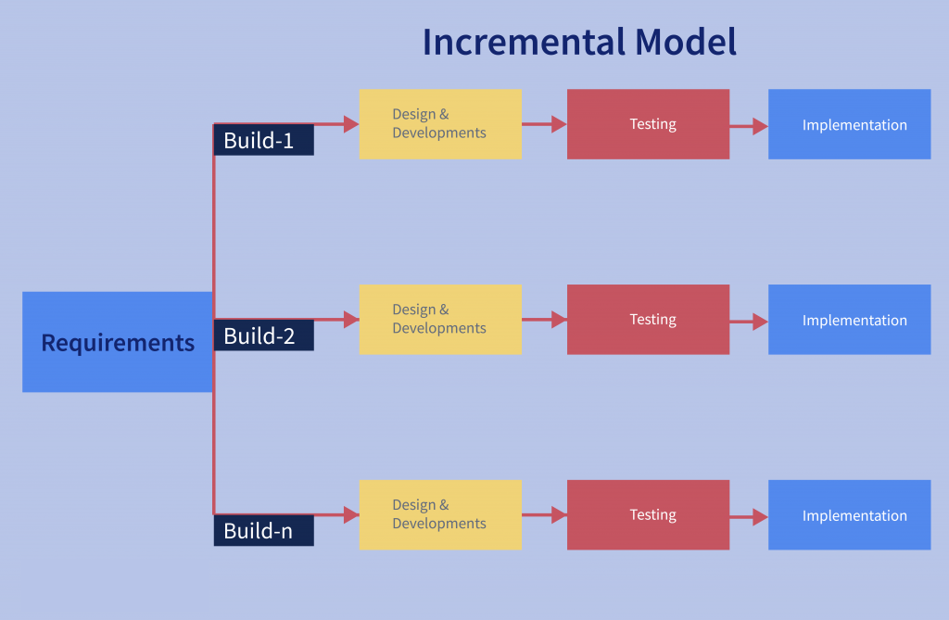

Figure 1 Increment Model Diagram

The various phases of incremental model are as follows:

**1. Requirement analysis:** In the first phase of the incremental model, the product analysis expertise identifies the requirements. And the system functional requirements are understood by the requirement analysis team. To develop the software under the incremental model, this phase performs a crucial role.

Requirement analysis for an E-Voting system with online upload of results using an incremental model involves breaking down the project into manageable components and defining the specific functionalities and features that the system must possess. Here's an overview of the key requirements:

**System Overview**

The E-Voting system should enables online voting with real-time result uploads and displays during elections. It's user-friendly and secure, with distinct roles (voters, EC, Polling officer) and specific responsibilities.

**User Roles**

Roles are well-defined for a smooth election process: voters focus on secure voting, the electoral commissioner manages all aspects, and polling officers assist voters with limited access. These roles and permissions are vital for a successful and secure election.

**Voter Registration**

The system implements a secure and user-friendly voter registration process. It guarantees that only eligible voters can register and take part in the elections, prioritizing both security and accessibility.

**Authentication and Security**

The system employs a robust authentication mechanism for secure user logins and incorporates encryption and other security measures to safeguard voter data and prevent unauthorized access, prioritizing security throughout.

**Voting Process**

The system features an intuitive online voting interface for user-friendly interactions. It ensures that voters can only cast their ballots within the designated election timeframe, effectively preventing multiple votes by the same voter for a single election, prioritizing ease of use and election integrity.

**Vote Counting and Result Generation**

The system establishes clear rules for vote counting and result generation, promoting accuracy and transparency. It supports incremental result updates, displaying the current tally as the election progresses, ensuring a transparent and reliable counting process.

**Incremental Result Upload**

The system implements a mechanism to incrementally upload and display results during the vote counting process. It specifies intervals for updating and publicly displaying results, enhancing transparency. Security measures are in place to guarantee the uploaded results remain secure and tamper-proof throughout the process.

**Data Backup and Recovery**

The system establishes regular data backups to prevent data loss during system failures and offers a recovery mechanism for restoring it to the last known stable state, ensuring data integrity and system reliability.

**Accessibility and Usability**

The system prioritizes accessibility by ensuring eligibility for all voters, including those with disabilities. It features a user-friendly interface with clear instructions, promoting ease of use and inclusivity.

**Audit and Logging**

The system incorporates an audit trail to record all user actions and maintains comprehensive logs of system activities for accountability and troubleshooting, enhancing transparency and accountability.

**Testing and Quality Assurance**

A comprehensive testing strategy is defined to ensure the system's functionality, security, and reliability. Regular testing, encompassing integration and security testing, is conducted to maintain the system's robustness and performance.

**Compliance and Legal Considerations**

The E-Voting system is meticulously designed to adhere to all pertinent electoral laws and regulations, ensuring legal compliance. It also addresses concerns related to voter privacy and data protection, prioritizing both legal adherence and voter data security.

**Scalability and Performance**

The system is engineered to efficiently manage a substantial influx of concurrent users during peak voting periods, prioritizing scalability. It also undergoes performance optimization to minimize response times, guaranteeing a seamless and user-friendly experience.

**Feedback Mechanism**

Implement a feedback mechanism to gather user feedback and suggestions for continuous improvement.

**Integration with Existing Systems**

Implement a feedback mechanism to gather user feedback and suggestions for continuous improvement.

**2. Design & Development:** In this phase of the Incremental model of SDLC, the design of the system functionality and the development method are finished with success. When software develops new practicality, the incremental model uses style and development phase.

Design & Development for an E-Voting system with online upload of results in an incremental model involves several stages. Here is a high-level overview of the process:

**Requirements Gathering**

Implement a feedback mechanism to gather user feedback and suggestions for continuous improvement.

**System Architecture Design**

A high-level architectural design is established to define system components and interactions. Technology, frameworks, and programming languages are selected to guide development.

**Database Design**

The database schema is carefully designed to store voter information, voting data, election results, and relevant data. Emphasis is placed on data integrity, security, and efficient retrieval, ensuring a robust and reliable database system.

**User Interface Design**

An intuitive and user-friendly interface is designed for voters, administrators, and election officials, with a strong emphasis on accessibility, responsiveness, and ease of use, prioritizing an inclusive and seamless user experience.

**Authentication & Security**

A robust authentication mechanism is implemented to verify user identities during login, while encryption and other security measures are employed to safeguard data from unauthorized access or tampering, ensuring strong user authentication and data security.

**Voter Registration Module**

A secure voter registration module is developed to enable eligible voters to register and verify their eligibility. Emphasis is placed on compliance with electoral regulations, ensuring a lawful and secure registration process.

**Voting Module**

The online voting module is implemented to enable secure voting during the election period. Measures are in place to prevent multiple votes by the same voter, ensuring both security and integrity in the voting process.

**Vote Counting & Result Generation**

Algorithms and rules for vote counting and incremental result tallying are developed. Real-time result updates are provided to the public during the election, ensuring transparency and timely access to election outcomes.

**Result Upload Module**

A specialized module is designed to enable election officials to securely upload results incrementally as they are counted. Robust security measures are in place to prevent any manipulation of the upload process, ensuring the integrity and accuracy of election results.

**Data Backup & Recovery**

Regular data backups are implemented to prevent data loss, while a reliable recovery mechanism is developed to restore the system in the event of failures, prioritizing data integrity and system reliability.

**Testing & Quality Assurance**

Comprehensive testing, including unit tests, integration tests, and security testing, is conducted. Identified issues or bugs are promptly addressed and resolved, ensuring the system's functionality, security, and reliability.

**Scalability & Performance Optimization**

The system's performance is optimized to effectively manage a high volume of concurrent users during peak voting periods. The infrastructure is scaled as required to meet escalating demands, ensuring seamless operation during times of heavy usage.

**Audit & Logging**

Implement an audit trail to log user actions and system activities for accountability and auditing purposes.

**Compliance & Legal Considerations**

Ensure the system adheres to all relevant electoral laws, privacy regulations, and data protection guidelines.

**User Training & Support**

Comprehensive training sessions are offered to election officials and administrators to ensure proficient use of the system. Additionally, user support is made available during the election period to promptly address and resolve any issues or queries, ensuring smooth and effective system operation.

**Deployment & Maintenance**

The E-Voting system is deployed in a production environment, followed by ongoing monitoring and maintenance to uphold its functionality and security, guaranteeing its sustained and secure operation.

**Continuous Improvement**

User feedback and suggestions for improvement are actively collected. Subsequently, updates and enhancements are implemented based on this valuable input and emerging requirements, ensuring the continuous improvement and relevance of the system.

**3. Testing:** In the incremental model, the testing phase checks the performance of each existing function as well as additional functionality. In the testing phase, the various methods are used to test the behaviour of each task.

Testing for an E-Voting system with online upload of results in an incremental model is a critical phase to ensure its reliability, accuracy, security, and user-friendliness. Here are the key testing areas:

**Functional Testing**

Verification is carried out to ensure the correct implementation of all functional requirements, including user registration, authentication, and voting processes. Additionally, testing is conducted to validate the accuracy of incrementally updated result displays, reflecting the ongoing vote counting accurately and comprehensively.

**Usability Testing**

The user interface is subject to evaluation to ensure it meets standards of intuitiveness, user-friendliness, and accessibility for all voters. User feedback is actively collected to pinpoint any usability issues and guide essential improvements, ensuring a seamless and inclusive user experience.

**Security Testing**

Security assessments are conducted to identify vulnerabilities and potential threats to the system. Rigorous testing is carried out to evaluate data encryption, secure authentication mechanisms, and measures for preventing unauthorized access, bolstering the system's robust security.

**Performance Testing**

The system undergoes performance assessments to ensure it handles concurrent users during peak voting periods and provides real-time updates without delays, contributing to a responsive user experience.

**Integration Testing**

Integration testing is conducted to ensure the seamless interaction of modules and components within the system. Verification includes confirming the smooth data flow between various parts of the system, ensuring overall functionality and cohesiveness.

**Data Validation Testing**

Data integrity checks and user input validation are carried out to prevent potential data corruption or manipulation risks. Additionally, testing includes assessing how the system handles invalid or unexpected user inputs, safeguarding against errors and vulnerabilities.

**Accessibility Testing**

Accessibility is a priority, ensuring the E-Voting system caters to all users, including those with disabilities. Thorough testing is conducted using various assistive technologies to confirm compliance with accessibility standards, enhancing inclusivity and usability for everyone.

**Scalability Testing**

The system's scalability is thoroughly tested to ensure it can efficiently manage a substantial volume of users and election data without experiencing performance degradation. Load testing is carried out to determine the system's breaking points and capacity, ensuring robust performance under heavy loads.

**Regression Testing**

Perform regression testing to ensure that new updates or fixes do not introduce new issues or break existing functionality.

**Disaster Recovery Testing**

Test the system's data backup and recovery mechanisms to ensure data can be restored in case of system failures or data loss.

**Compliance Testing**

Verify that the E-Voting system complies with all relevant electoral laws, privacy regulations, and data protection guidelines.

**User Acceptance Testing (UAT)**

Involve real users in the testing process to evaluate the system's usability and functionality from their perspective.

**Penetration Testing**

Conduct penetration tests to identify potential security vulnerabilities and assess the system's resistance to hacking attempts.

**Audit and Logging Verification**

Verify that the system's audit trail and logging mechanisms are accurately capturing all relevant activities.

**4. Implementation:** Implementation phase enables the coding phase of the development system. It involves the final coding that design in the designing and development phase and tests the functionality in the testing phase. After completion of this phase, the number of the

**System Setup**

Set up the development environment, including servers, databases, and required software frameworks.

**Database Design and Setup**

The database schema is created based on the designed structure to store voter information, voting data, and election results. Necessary tables and relationships are set up for organized data management.

**User Authentication**

A secure authentication system is implemented, enabling users (voters, Electoral administrators, and election officials) to log in securely. Robust encryption and secure hashing techniques are employed to safeguard user credentials, ensuring strong security measures for user authentication.

**Voter Registration Module**

The voter registration module is developed to enable eligible voters to securely register by providing required details and verifying their eligibility. Validation mechanisms are implemented to prevent duplicate or invalid registrations, ensuring an efficient and secure registration process.

**Voting Module**

The online voting module is created, allowing voters to securely cast their ballots during the specified election period. It's designed to enforce a one-vote-per-voter rule for a specific election, ensuring both security and fairness in the voting process.

**Vote Counting and Result Generation**

Algorithms and rules are developed to accurately count votes and incrementally generate election results. The logic is designed to provide real-time updates and display results as the election progresses, ensuring transparency and timely access to information during the ongoing election.

**Result Upload Module**

A secure module is implemented to enable election officials to safely upload and publish results incrementally as they are counted and verified. Robust security measures are in place to prevent any manipulation of the uploaded results after publication, guaranteeing the integrity and authenticity of the election outcomes.

**User Interface Development**

User interfaces are meticulously designed and developed for voters, administrators, and election officials, emphasizing intuitiveness and user-friendliness. These interfaces are optimized for responsiveness and accessibility, ensuring a seamless user experience across various devices and browsers.

**Security Measures**

The implementation incorporates an array of security measures, encompassing data encryption, secure communication through HTTPS, and safeguards against common web vulnerabilities like SQL injection and cross-site scripting. Ongoing security assessments and vulnerability testing are conducted regularly, enhancing the system's robust security posture.

**Testing and Quality Assurance**

Comprehensive testing procedures are executed, spanning unit testing, integration testing, functional testing, and usability testing. Any issues or bugs identified during testing are diligently addressed and resolved, ensuring the system's functionality and user experience meet high standards.

**Deployment and Scaling**

The E-Voting system is deployed to production servers or cloud platforms, supported by scaling mechanisms that effectively manage increased traffic during peak voting periods, ensuring reliable and responsive operation.

**Backup and Recovery**

Set up automated data backups and implement recovery procedures to ensure data integrity and availability.

**Compliance and Legal Considerations**

Ensure the system adheres to all relevant electoral laws, privacy regulations, and data protection guidelines.

**Training and Support**

Comprehensive training equips election officials and administrators, and ongoing user support is offered during the election period for efficient system use.

**Continuous Improvement**

User feedback is actively collected, and system performance is continuously monitored to pinpoint areas for improvement. Regular updates and enhancements are implemented to ensure the system remains aligned with evolving needs and requirements, fostering ongoing improvement and adaptability.

### **3.3 System Design**

#### **3.3.1. Use Case Analysis**

Use Case: E-Voting System with Online Upload of Results

Primary Actor: Voter

Secondary Actors: Election Administrator (EC), Polling Officer

**Preconditions:**

* The E-Voting system is set up and running.
* Voters are registered and have the necessary authentication credentials.
* Election administrators have access to the system.
* Polling Officer have access to the system to monitor election.

**Use Case Flow:**

**1. Voter casts vote:**

* The voter logs into the E-Voting system using their authentication credentials.
* The system presents the available candidates/options to the voter.
* The voter selects their preferred candidate/option and submits the vote.
* The system verifies the eligibility of the voter and ensures the vote is valid.
* The system encrypts and securely stores the vote in the database.

**2. Tabulation of Votes:**

* Once the voting period ends, the election administrator initiates the tabulation process.
* The system retrieves the encrypted votes from the database.
* The system decrypts the votes and aggregates them based on the selected candidates/options.
* The system generates a tabulated result for each candidate/option.

**3. Results Upload:**

* The election administrator reviews and verifies the tabulated results.
* Once verified, the election administrator uploads the final results to the system for online publication.
* The system authenticates the election administrator credentials.
* The system securely uploads the results to a designated online platform or website.

**4. Result Verification:**

* Voters, candidates, and other polling officers access the online platform or website to verify the results.
* The online platform presents the tabulated results, allowing voter to view the outcome.
* Voters and polling officers can compare the published results with their individual votes or their preferred candidate/option.

#### **3.3.2 Use Case Diagram**

A use case diagram is a visual representation that depicts the interactions between actors (users or external systems) and a system. It shows the various use cases or scenarios in which the system is used and illustrates how the actors interact with the system to achieve specific goals or tasks. The use case diagram helps to define the functional requirements of the system and provides an overview of its behaviour from a user's perspective. The illustration below shows the use case diagram of E-Voting system with Online Upload of results.

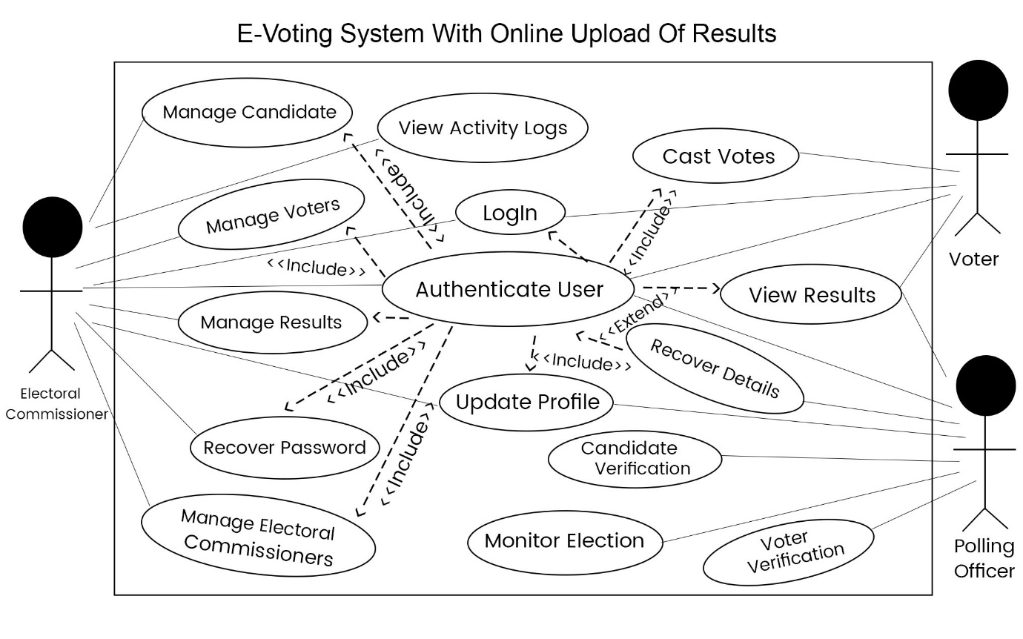

Figure 2 Usecase Diagram for the System

#### **3.3.3 Flowchart Diagram**

A flowchart diagram is a visual representation that outlines the sequence of steps or actions in a process or system. It uses standardized symbols to depict the flow of control, data, and decisions within the process. Flowcharts provide a clear and structured view of how a process works, allowing stakeholders to understand the logical flow and identify potential bottlenecks or areas for improvement. They are widely used in various industries to document, analyze, and communicate complex processes in a visual and intuitive manner. The illustration below shows the flowchart diagram of E-Voting system with Online Upload of results.

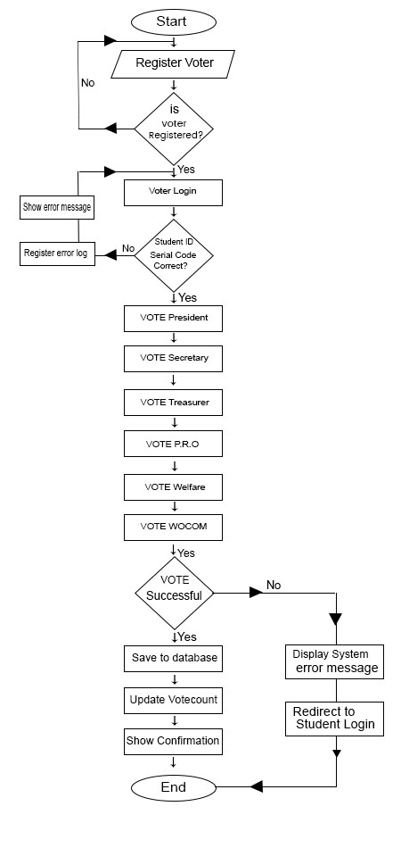

Figure 3 Flowchart Diagram for the System

#### **3.3.4 System Architecture Diagram**

System architecture design refers to the process of creating a high-level plan or blueprint that defines the structure, components, and interactions of a software system. It involves identifying the key components, their relationships, and how they work together to achieve the desired functionality and meet the system requirements. System architecture design provides a foundation for building, deploying, and maintaining a software system, ensuring it is scalable, reliable, maintainable, and meets the needs of stakeholders.

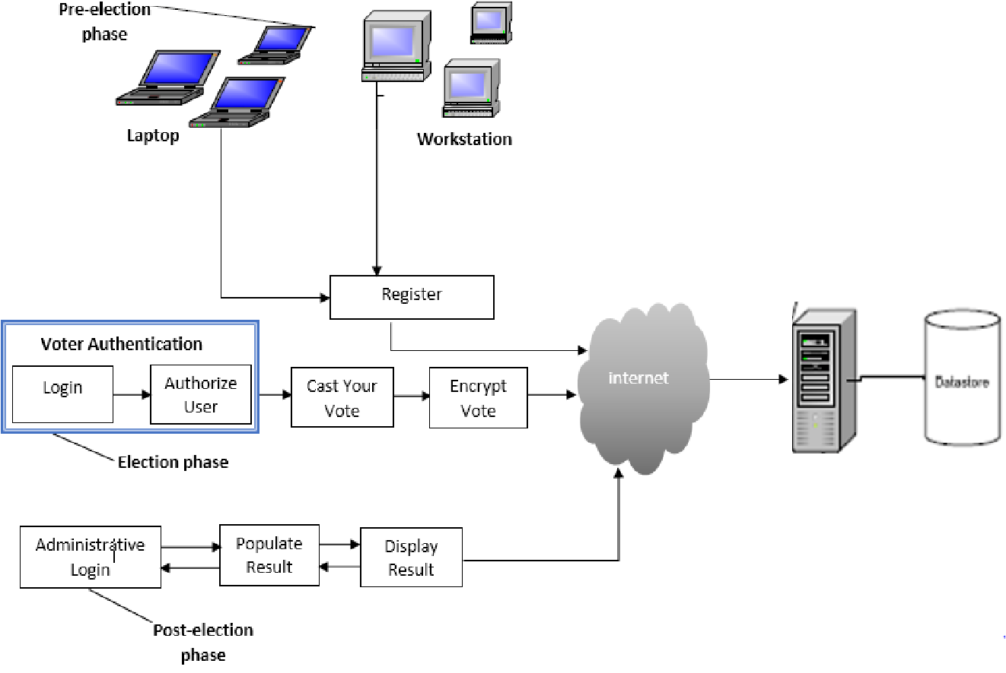

Figure 4 System Architecture diagram for the System

#### **3.3.5 Entity Relationship Diagram**

Entity-relationship (ER) design is a process of modelling and designing the structure and relationships of entities in a database. It involves identifying entities (objects, concepts, or things) and the relationships between them, as well as defining the attributes (properties) of each entity. The ER design captures the logical representation of the data and helps in visualizing how different entities are related to each other. It is commonly used in database design to create a conceptual model that serves as a blueprint for creating a database schema. The ER design helps ensure data integrity, define the database structure, and establish the relationships between entities, facilitating efficient data management and retrieval.

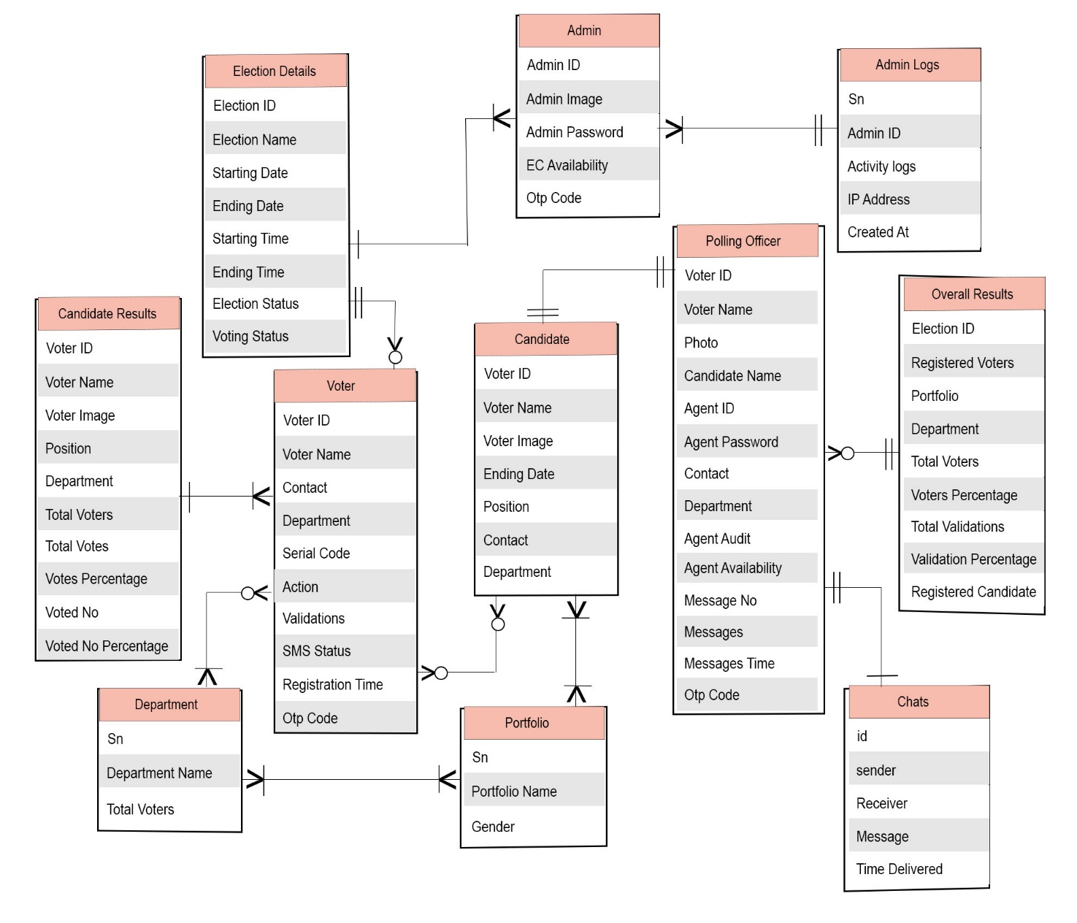

Figure 5 Entity Relationship Diagram for the System

#### **3.3.6 Data Flow Diagram**

A Data Flow Diagram (DFD) is a traditional visual representation of the information flows within a system. A neat and clear DFD can depict the right amount of the system requirement graphically. It can be manual, automated, or a combination of both. It shows how data enters and leaves the system, what changes the information, and where data is stored. The objective of a DFD is to show the scope and boundaries of a system as a whole. It may be used as a communication tool between a system analyst and any person who plays a part in the order that acts as a starting point for redesigning a system. The DFD is also called as a data flow graph or bubble chart.

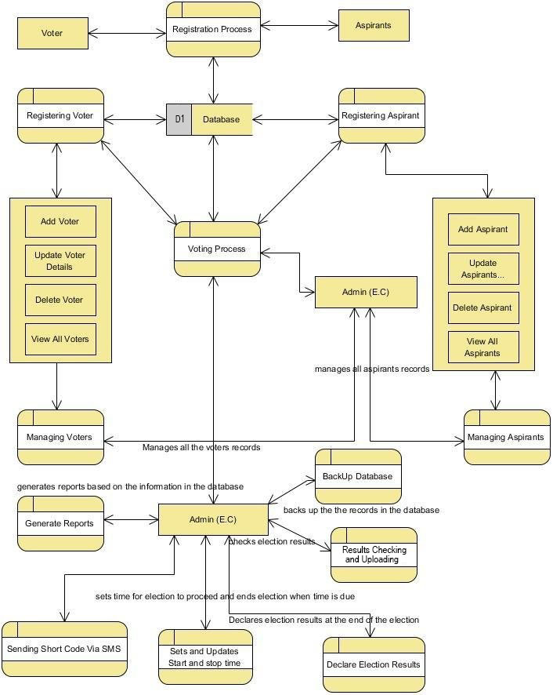

Figure 6 Data flow diagram for the system

#### **3.3.6 Image type that is Support**

When building an E-voting system with online result upload you can support various image types based on the capabilities of the technologies involved. Here are commonly supported image types that can be used:

1. JPEG (Joint Photographic Experts Group):

* Extension: .jpg, .jpeg
* Well-suited for photographs and complex images with rich colors.
* Lossy compression format that balances image quality and file size.

2. PNG (Portable Network Graphics):

* Extension: .png
* Supports lossless compression, preserving image quality without significant reduction.
* Suitable for images with transparency, logos, icons, or graphics with sharp edges.

3. GIF (Graphics Interchange Format):

* Extension: .gif
* Supports animations and a limited color palette.
* Often used for simple graphics, logos, or small animations.

4. SVG (Scalable Vector Graphics):

* Extension: .svg
* Uses XML-based markup to describe vector-based graphics.
* Ideal for graphics that need to scale without loss of quality, such as icons or logos.

# **CHAPTER FOUR**

# **SYSTEM IMPLEMENTATATION AND DESIGN**

The objective of this chapter is to provide class diagrams, structure of their program or sequence diagram to show the implementation and the interaction of the various classes or modules. This chapter also aims to providing description of the various interfaces and their functions. This chapter also include testing interfaces and the various error messages provided by the system in terms of vulnerabilities, wrong entry, and wrong operations all captured as snap shots.

### **4.1 Class Diagram**

Class design refers to the process of creating the detailed structure and behavior of individual classes in object-oriented programming. It involves defining the properties (attributes) and behaviors (methods) of a class, as well as the relationships and interactions between classes. Class design focuses on designing reusable, cohesive, and well-organized classes that encapsulate data and behavior, promote modularity, and facilitate code readability, reusability, and maintainability. It is a crucial step in software development that helps translate system requirements into implementable code by designing the building blocks of the system - the classes.

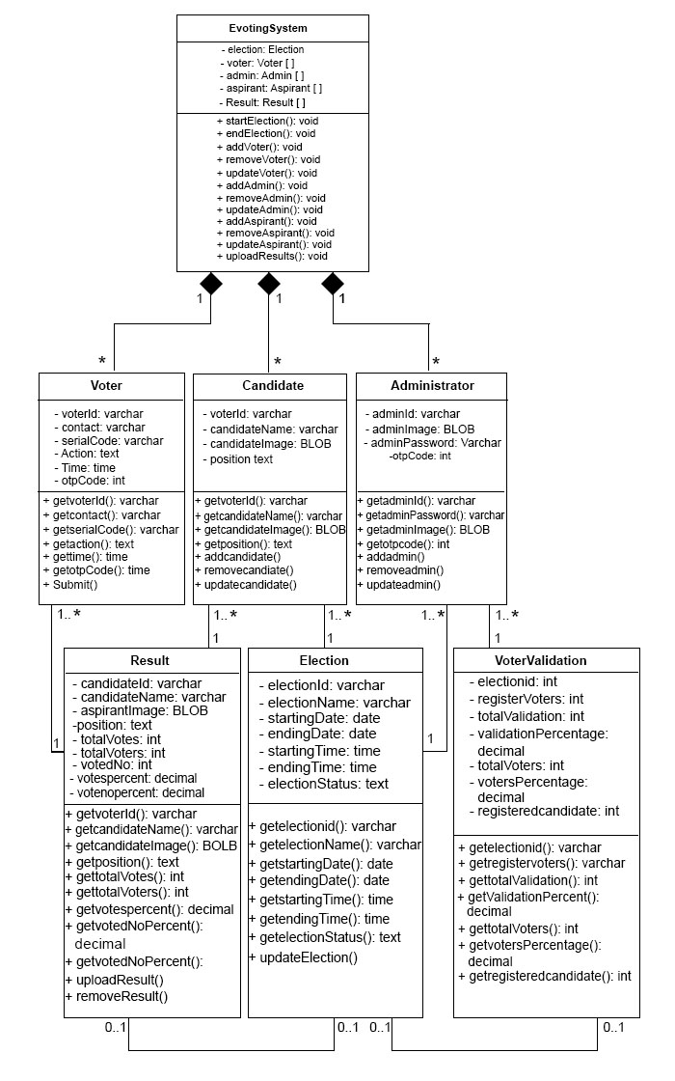

Figure 7 Class Diagram for the System

### **4.2 Sequence Diagram**

A sequence diagram is a visual representation that illustrates the interactions and messages exchanged between objects or components within a system. It shows the chronological order in which these interactions occur over time. Sequence diagrams focus on the time-based behavior of a system, emphasizing the sequence of method calls and responses between objects or components. They provide a clear and concise view of how different parts of a system collaborate to achieve a particular functionality or process. Sequence diagrams are widely used in software development to design, document, and analyze the dynamic behavior of systems or subsystems.

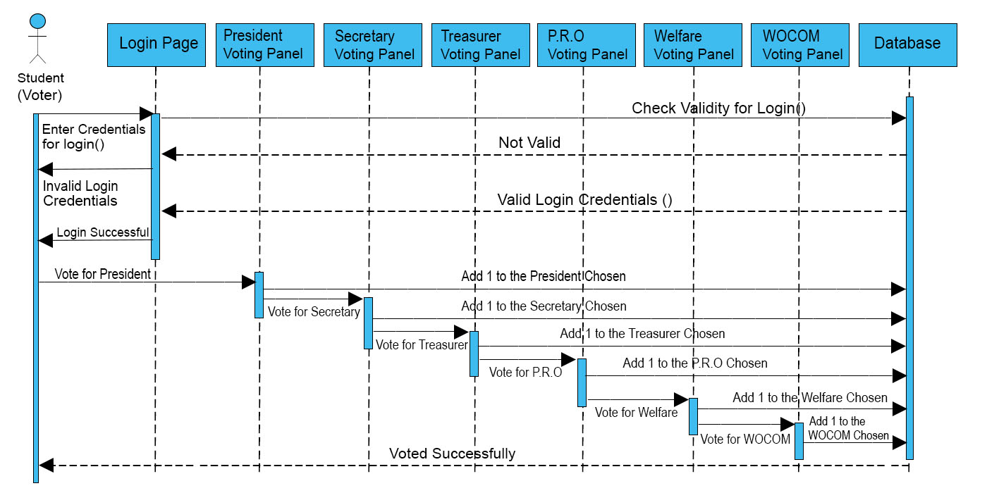

Figure 8 Sequence Diagram for the System

### **4.3 System Interface**

The system interface is the point of communication between the computer user and the computer; thus, it allows the users (admin and voters) to interact with system. After logging in as an admin or voter. The admin register voters, aspirants, add election settings and upload election results while after voter logs in. He or she cast his or her cast vote and view the result of the election after election is closed.

#### **4.3.1 Homepage**

The homepage for elections includes sections for services, about information, and user roles, catering to Electoral Commissioners and Polling Agents. It also features a "Sign In" button for voters where the voter can sign in to cast votes or view results after voting period ends.

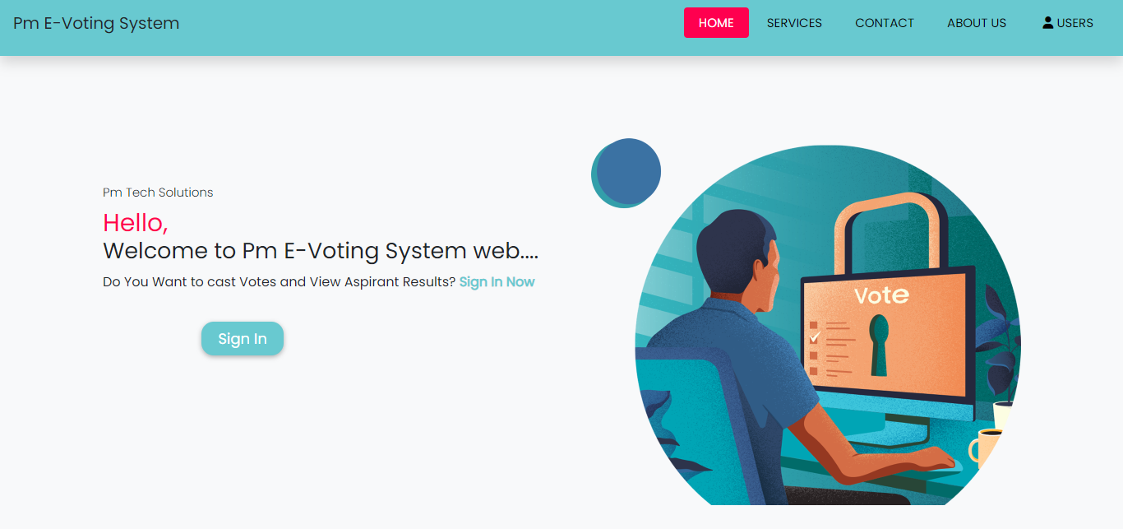

Figure 9 Homepage Interface

**1. Contact Us Interface**

Contact us interface or section provides various ways to reach the electoral commissioner, including phone numbers, email, and a contact form. You can also connect with us on social media. For urgent issues, emergency contact number or form are provided. Because feedbacks are important, for support and assistance ensuring transparency in the electoral process.

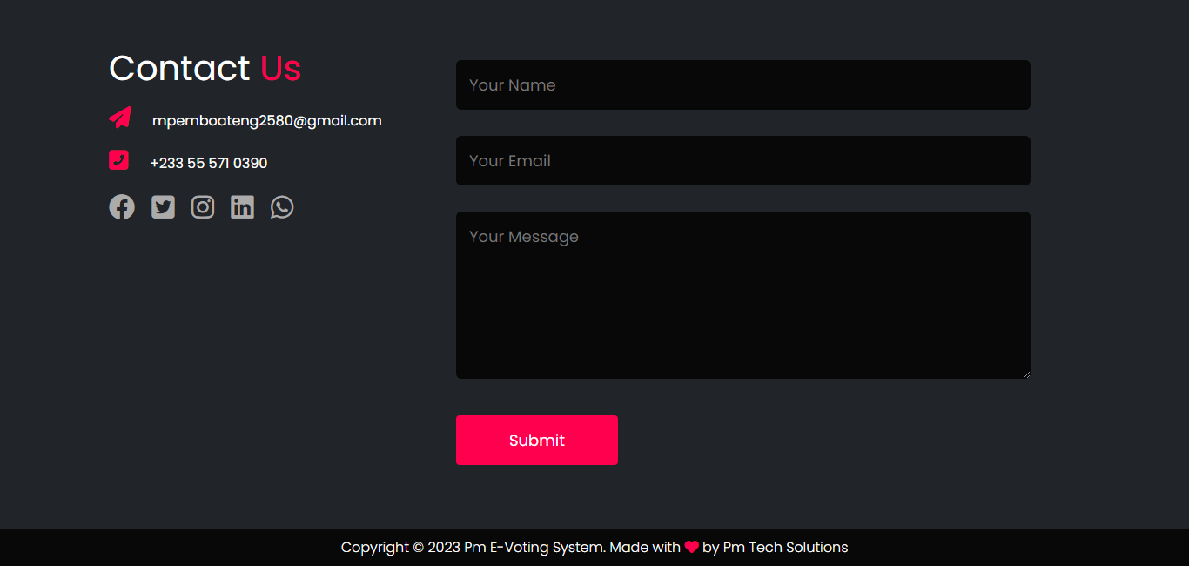

Figure 10 Contact Us Interface

**2. About Us Interface**

This section offers information about the electoral commission or organization responsible for managing elections. It may include the commission's mission, history, and contact details. This helps users understand the authority behind the electoral process.



Figure 11 About Us Interface

#### **4.3.2 Voter Login Interface**

**1. Cast Votes Login Interface**

The login interface platform provides a secure gateway for registered voters to access the voting system. Here, voter input their unique credentials, such as voter ID, along with a serial code. Once successfully authenticated, voters gain entry to their personalized voting options.

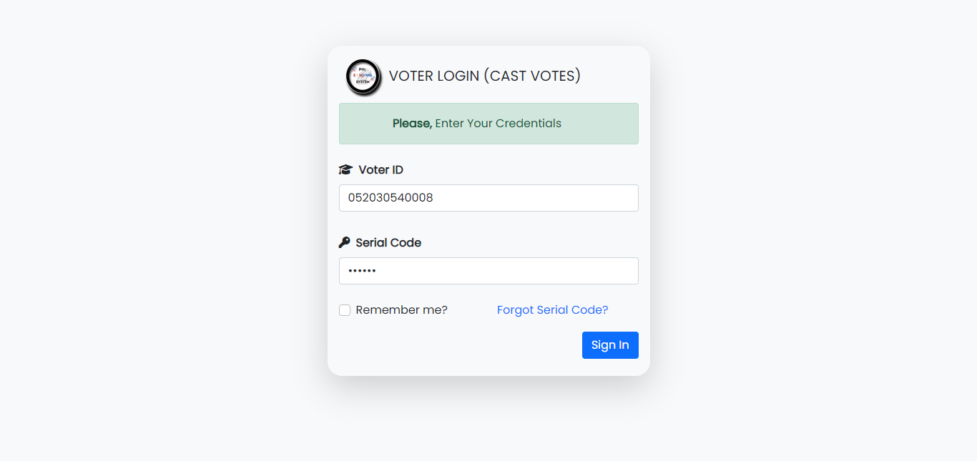

Figure 12 Voter Login for Casting Vote

**Voting Interface**

Voting interface ensures a straightforward and confidential process. It presents candidates or options, allows selections. After confirmation, voters receive assurance of their securely recorded choices.

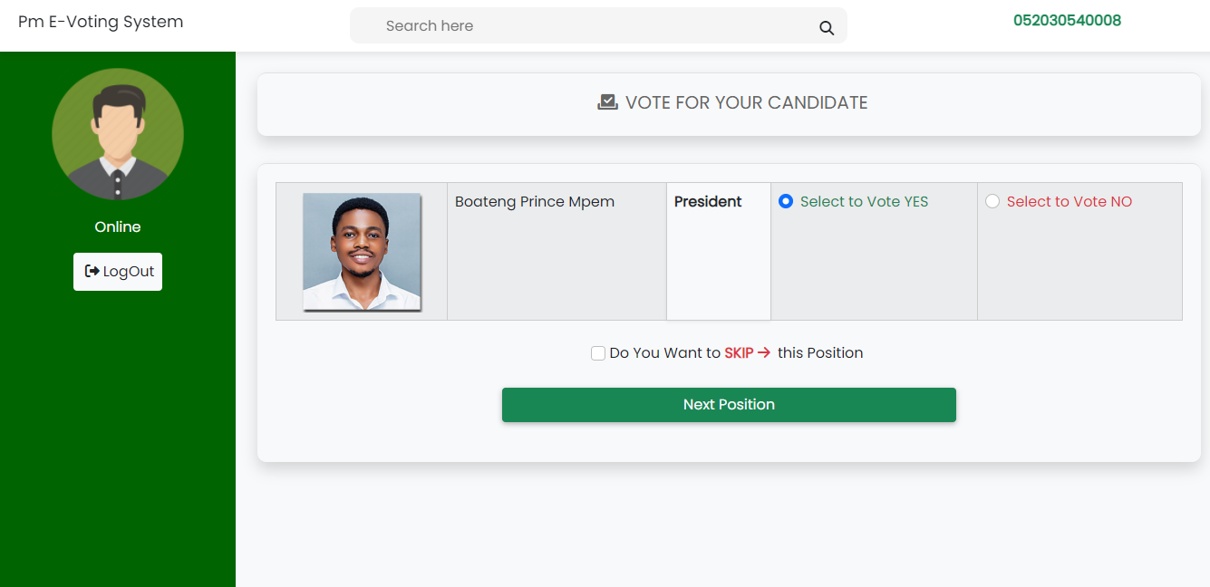

Figure 13 Voter Voting Interface

**2. View Results Login Interface**

The login interface platform provides a secure gateway for registered voters to access election results. Here, voter input their unique credentials, such as voter ID, along with a serial code. Once successfully authenticated, voters gain entry to view election results immediately when voting period is closed.

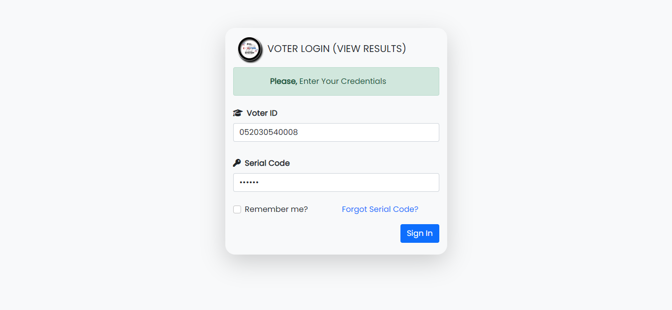

Figure 14 Voter Login for Viewing Results

**Election Results Interface**

The Election Results Interface offers real-time election updates for voters, including candidate standings and performance, in a user-friendly format.

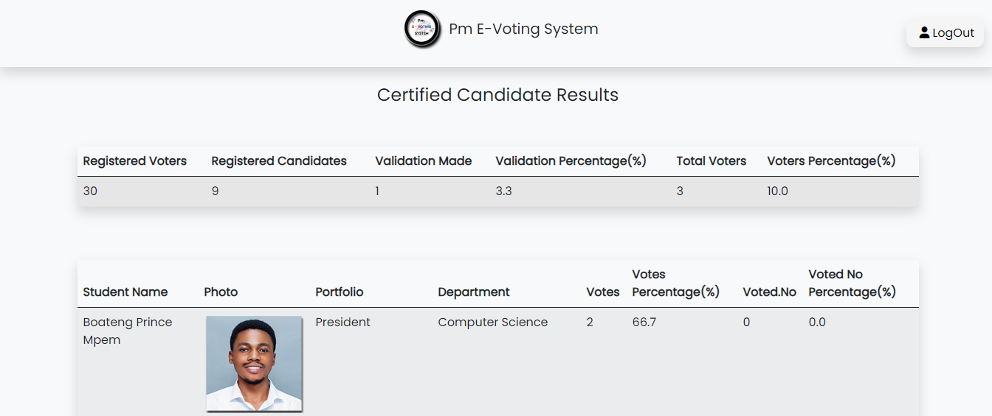

Figure 15 Election Result Interface for Voters

**3. Voter Forgot Serial Code Interface**

The Voter Forgot Serial Code Interface is a helpful tool for registered voters who have misplaced or forgotten their unique serial codes. It enables users to retrieve their serial codes securely by providing necessary identification information, such Voter ID and Contact or Phone number. After providing a valid details an OTP will be sent via voter’s phone number provides. This interface streamlines the process of obtaining lost serial codes, ensuring that eligible voters can participate in the electoral process without unnecessary barriers.

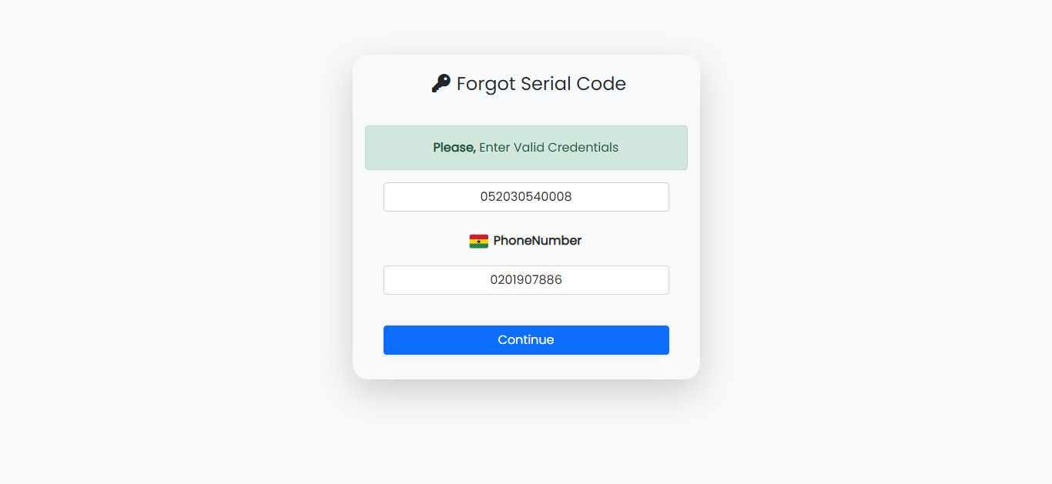

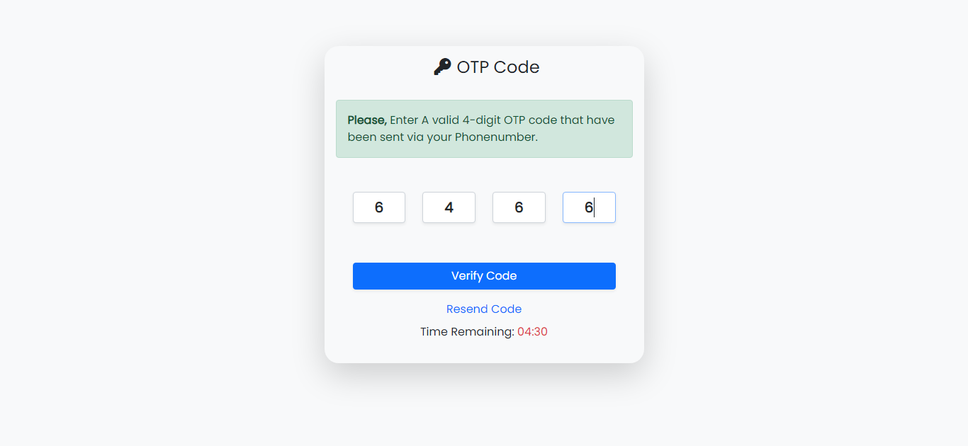

Figure 16 Forgot Serial Code for Voters

#### **4.3.3 Electoral Commissioner**

**1. EC Login Interface**

The Electoral Commissioner login interface is a secure web based application platform that allows authorized Electoral Commissioners to manage and control a system. Access to the EC interface requires a unique EC ID and a corresponding password for authentication. Once logged in, Electoral Commissioner can perform tasks like managing Candidates, managing voters, setting a valid time and date for voting and monitoring analytics.

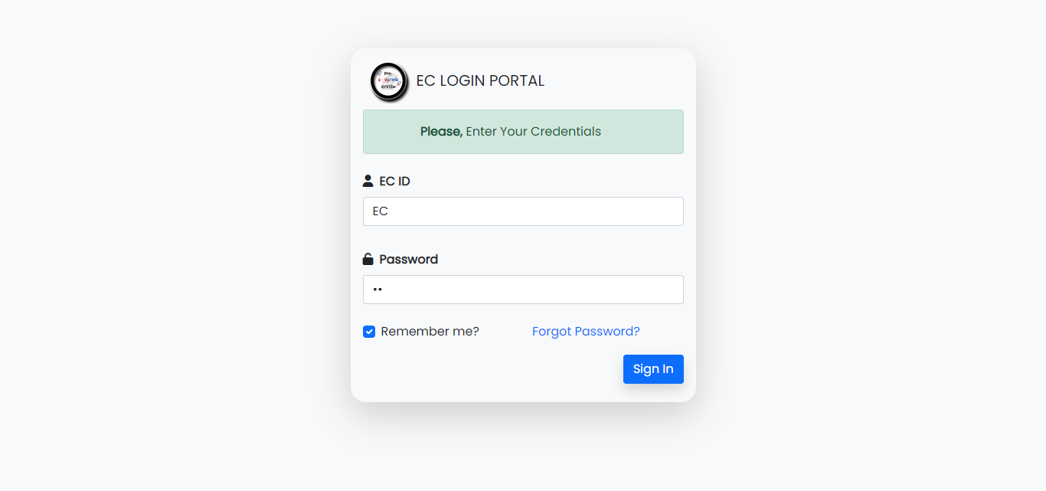

Figure 17 EC Login Interface

**2. Dashboard Interface**

The EC Dashboard Interface is a comprehensive platform that provides essential election-related information at a glance. Users, including Electoral Commissioners and election administrators, can access crucial data such as the total number of registered voters, the election date and time, and other pertinent details. This user-friendly interface facilitates efficient decision-making and monitoring of electoral processes, ensuring that all stakeholders have real-time access to essential information for the smooth conduct of elections.

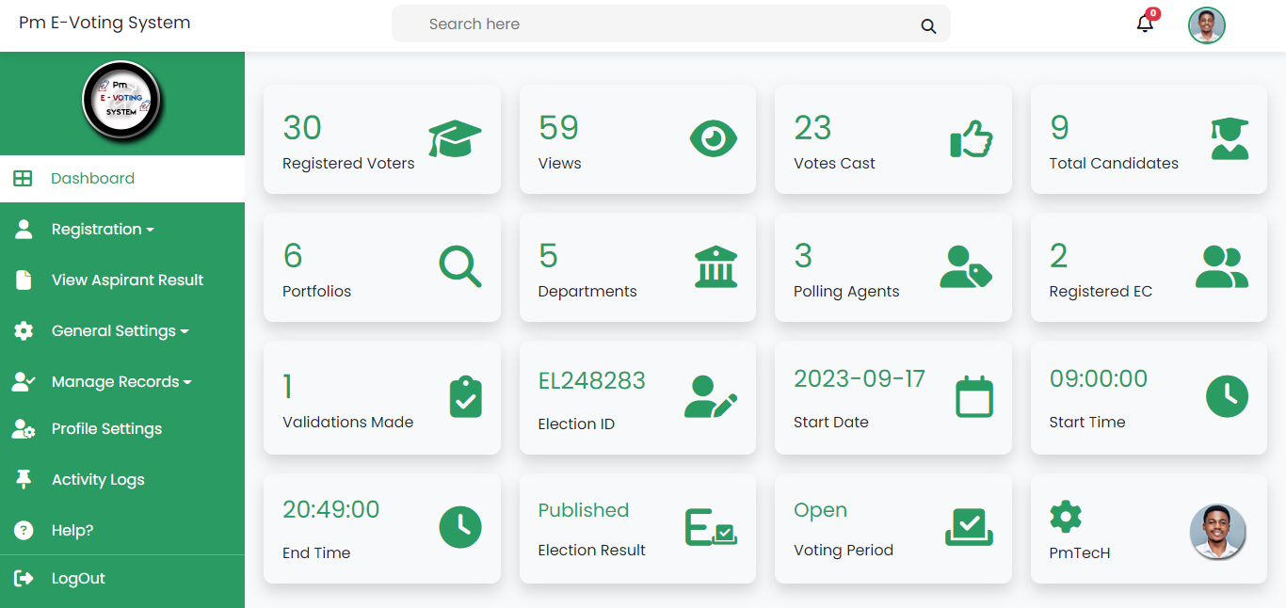

Figure 18 EC Dashboard

**3. New EC Account Interface**

Registering a new EC (Electoral Commission) account involves a straightforward process where electoral commissioner, create their profiles to gain access to the EC's administrative tools and resources. ECs provide essential information and follow security protocols to ensure the integrity of the registration process. Once registered, they can effectively manage and oversee electoral activities.

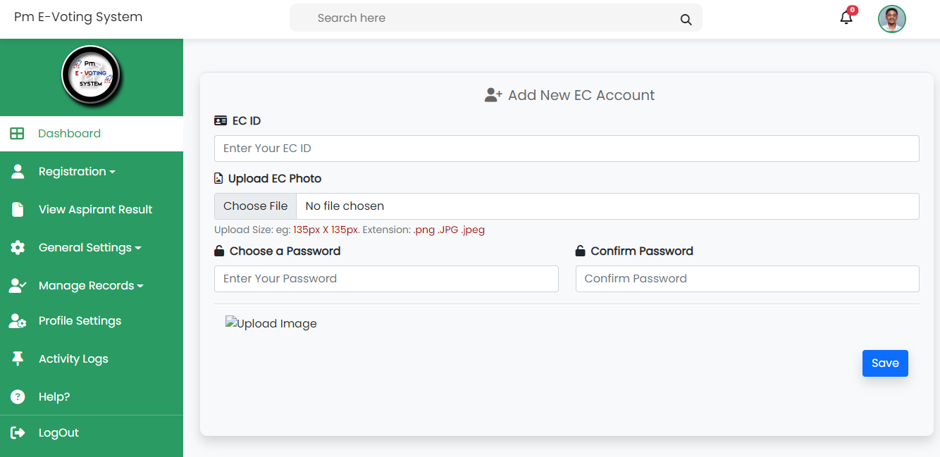

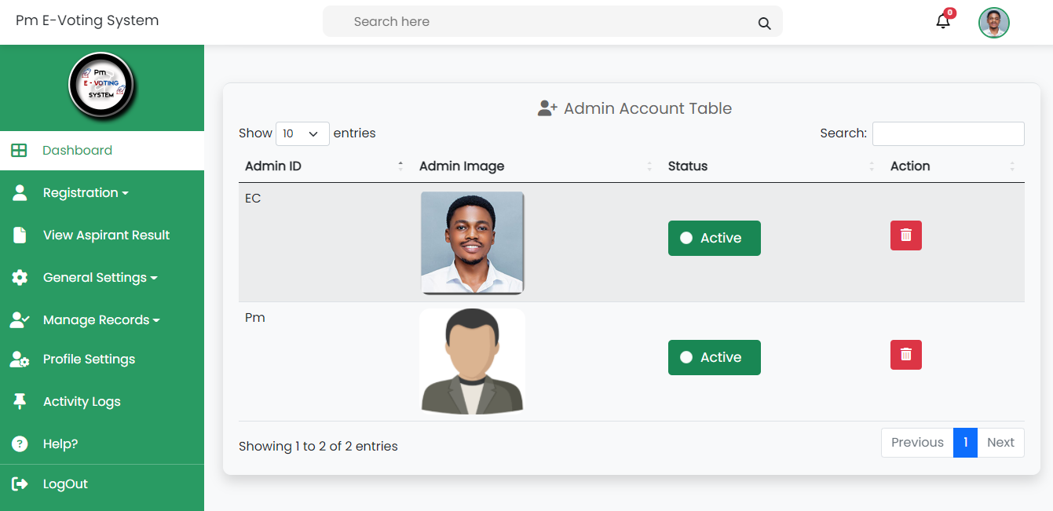

Figure 19 Registering New EC Account Interface

**4. Voter Registration Interface**

The Voter Registration Interface simplifies the voter registration process, accommodating both individual registrations and bulk imports for efficiency. Individuals can complete their registration by providing and submitting necessary information to the EC, while EC can streamline the process by importing large lists of voters via CSV files. This interface ensures a seamless and inclusive voter registration experience, whether for single registrations or handling substantial voter databases.

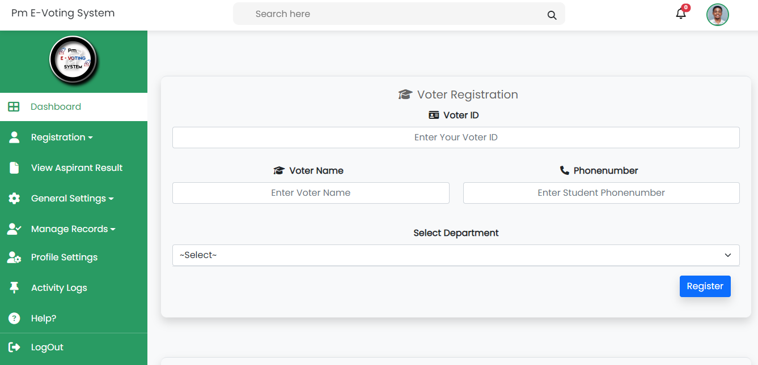

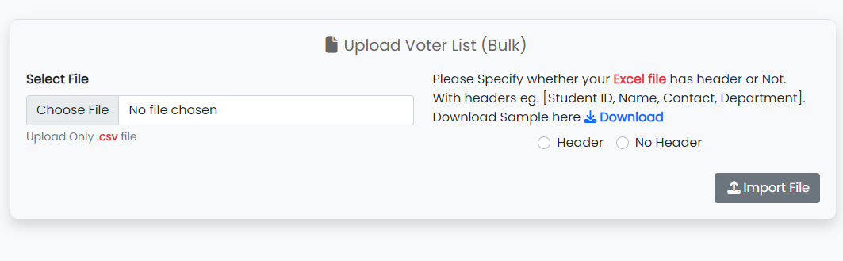

Figure 20 Voter Registration Interface

**5. Candidate Registration Interface**

The Candidate Registration Interface offers a two-step process to ensure eligibility and facilitate the registration of candidates. First, it checks if the person is already registered as a voter by verifying their voter ID. If confirmed, users can proceed to select the candidate's photo and position before finalizing the registration. This streamlined approach ensures that only eligible individuals are considered as candidates in the electoral process, enhancing the integrity of the candidate selection process.

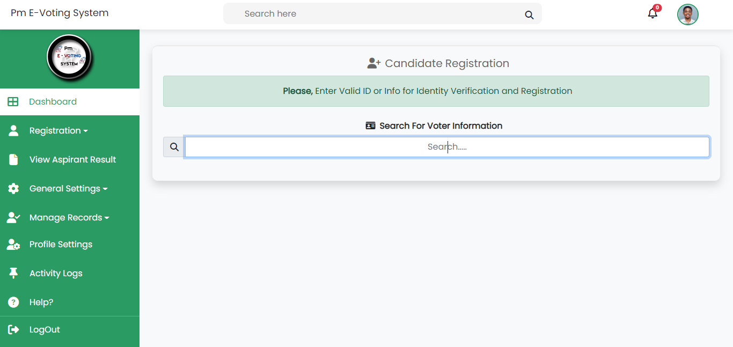

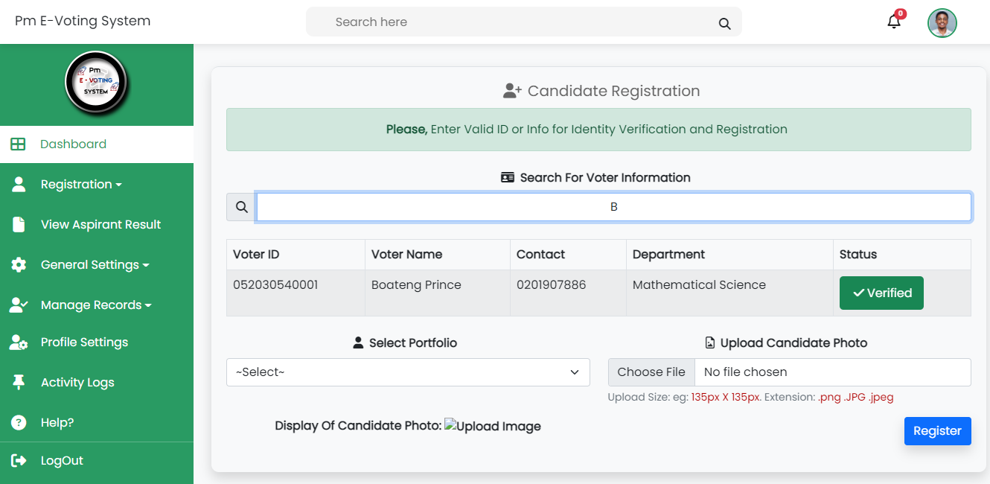

Figure 21 Candidate Registration Interface

**6. EC View Election Results Interface**

The EC View Election Results Interface serves as a central hub for Electoral Commission (EC) officials to review, audit, and publish election results. It provides EC members with the capability to access and verify the results before making them public. Additionally, this interface empowers the EC to remove or withhold results when necessary, ensuring accuracy and transparency in the electoral process.

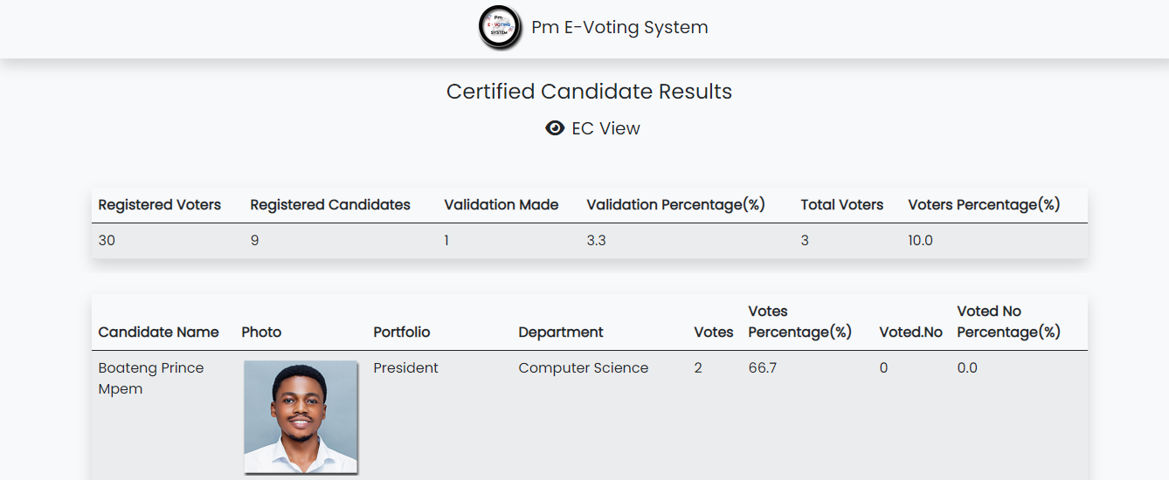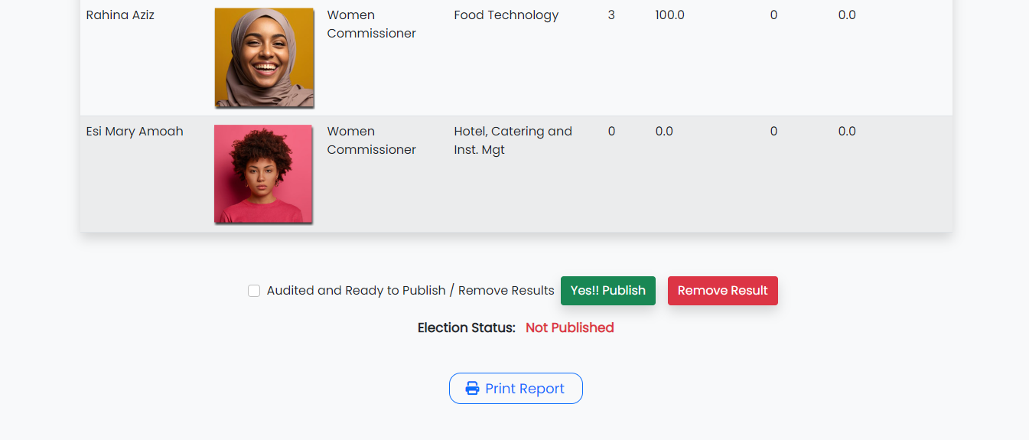

Figure 22 EC View Election Results Interface

**7. General Settings Interface**

**Election Settings Interface**

The Election Settings Interface is a pivotal tool for Electoral Commission (EC) administrators to configure key parameters for the electoral process. It allows the EC to set the date and time for the election, including an automated voting close time. Additionally, the EC has the authority to manually open or close the voting process within the present election timeframe. This interface grants flexibility and control to ensure the smooth and efficient management of elections according to established schedules and protocols.

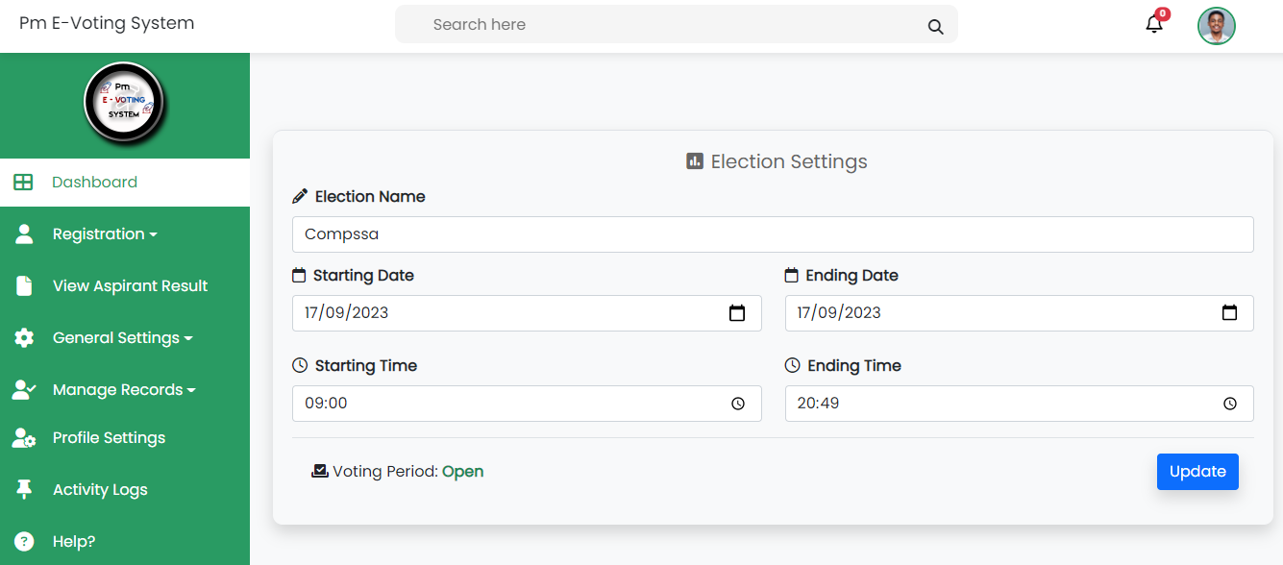

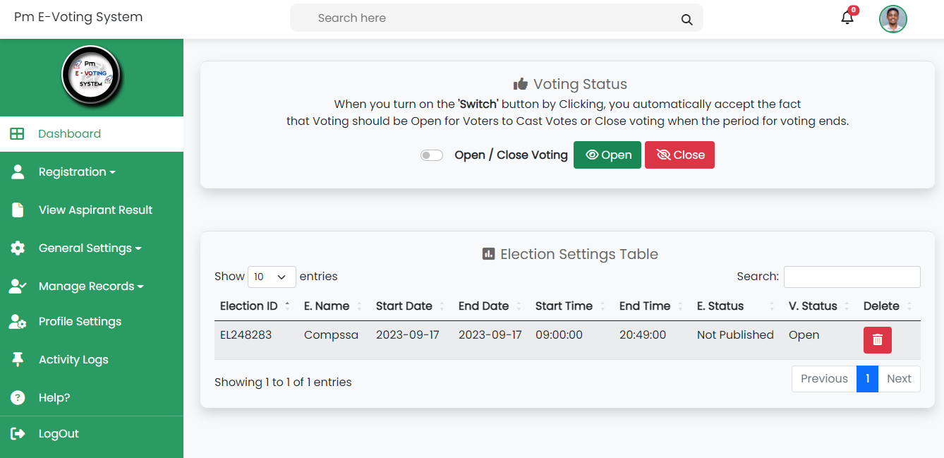

Figure 23 Election Settings Interface

**Portfolio Interface**

The Portfolio Interface enables EC to efficiently register portfolio names and gender information for individuals holding specific roles or positions.Which the EC can delete any portfolio he wants.

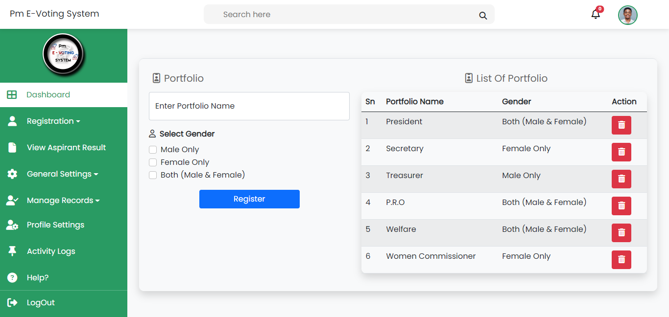

Figure 24 Portfolio Registration Interface

**Department Interface**

The Department Interface facilitates the registration of departments by entering their names and the number of associated voters. Additionally, it grants the Electoral Commission (EC) the authority to delete departments as needed, providing efficient management control over departmental data within the electoral system.

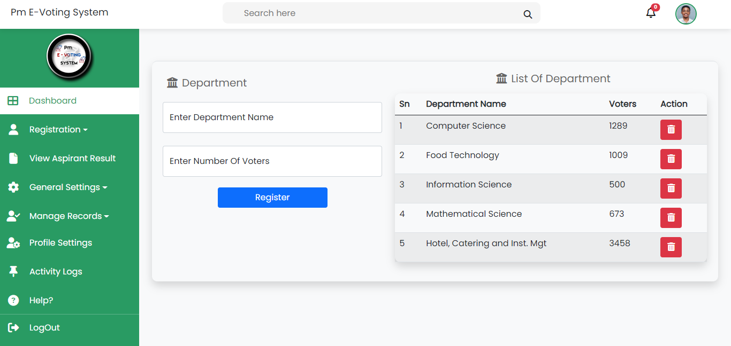

Figure 25 Department Registration Interface

**9. Manage Voters Interface**

The Manage Voters Interface empowers the Electoral Commission (EC) to oversee voter-related tasks efficiently. Within this interface, the EC can update voter information, delete voter records, and send SMS notifications containing voting credentials to voters, either individually or in bulk. The interface also provides visibility into the status of sent SMS messages, indicating voter validation, and allows the EC to monitor those who have successfully cast their votes in the election. This comprehensive tool enhances the management and communication processes associated with voters during electoral events. Which all the list of the voters can be exported as CSV or Truncated.

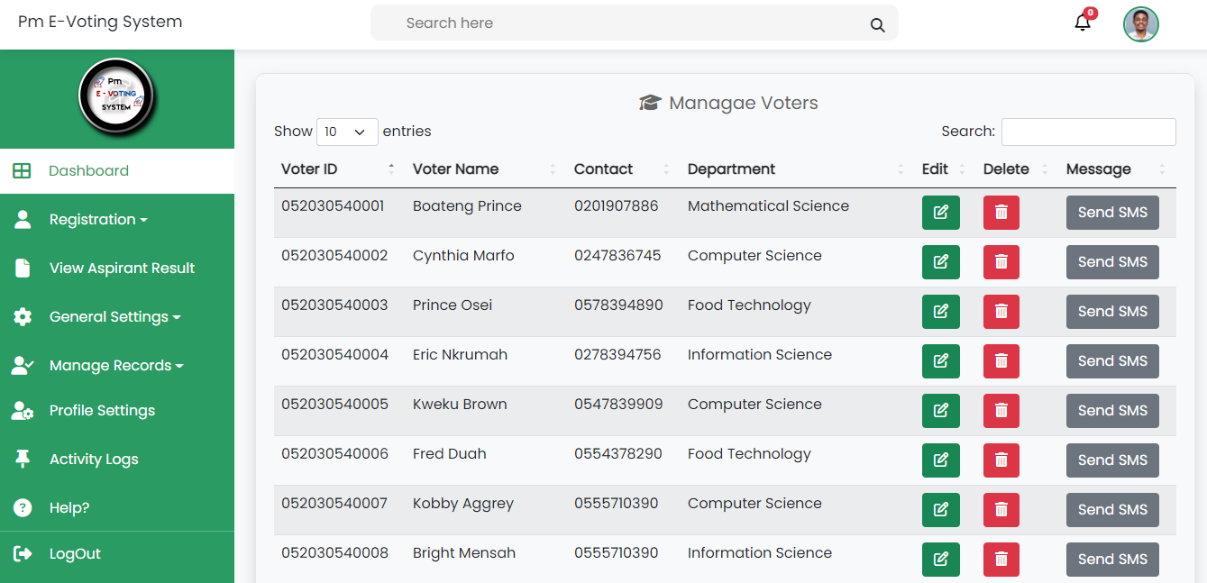

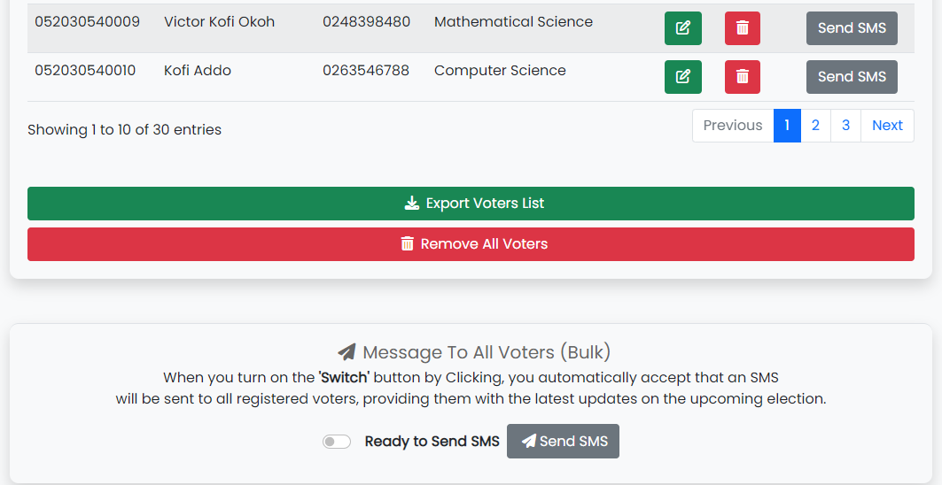

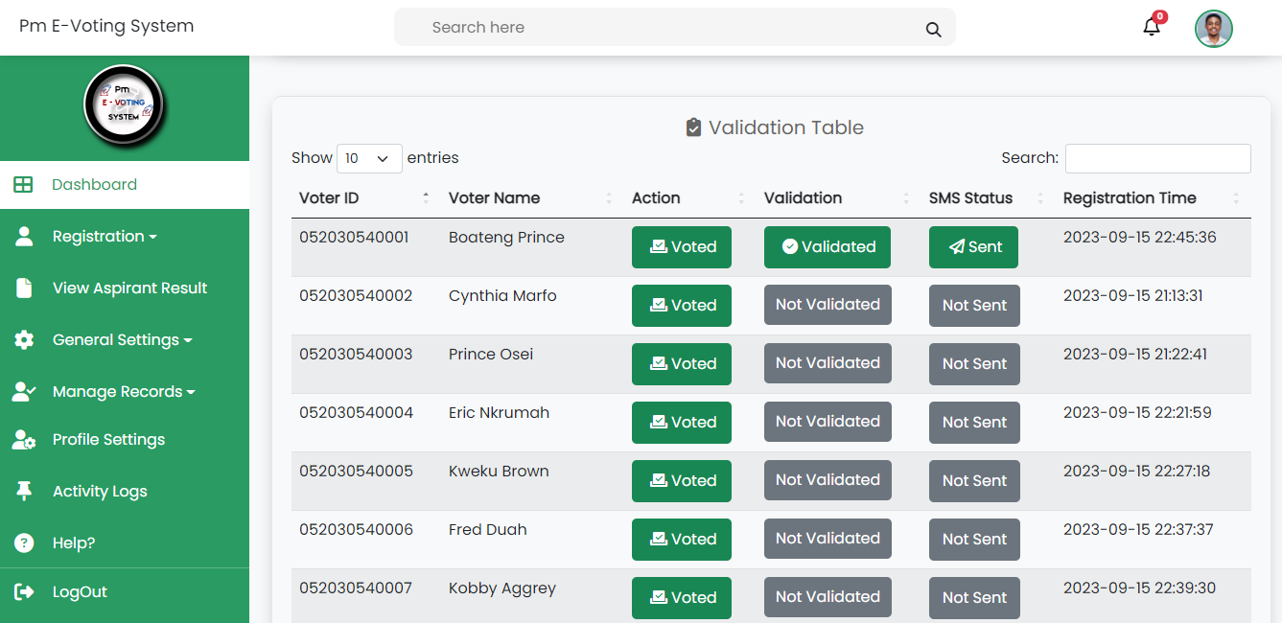

Figure 26 Voter Management Interface

**10. Manage Candidates Interface**

The Manage Candidates Interface facilitates the efficient management of candidate information by the Electoral Commission (EC). Within this interface, the EC can easily update and delete candidate records. Additionally, the system offers the functionality to export the complete list of candidates as a CSV file, streamlining administrative tasks and enhancing data organization. This user-friendly tool simplifies the oversight of candidates in the electoral process.

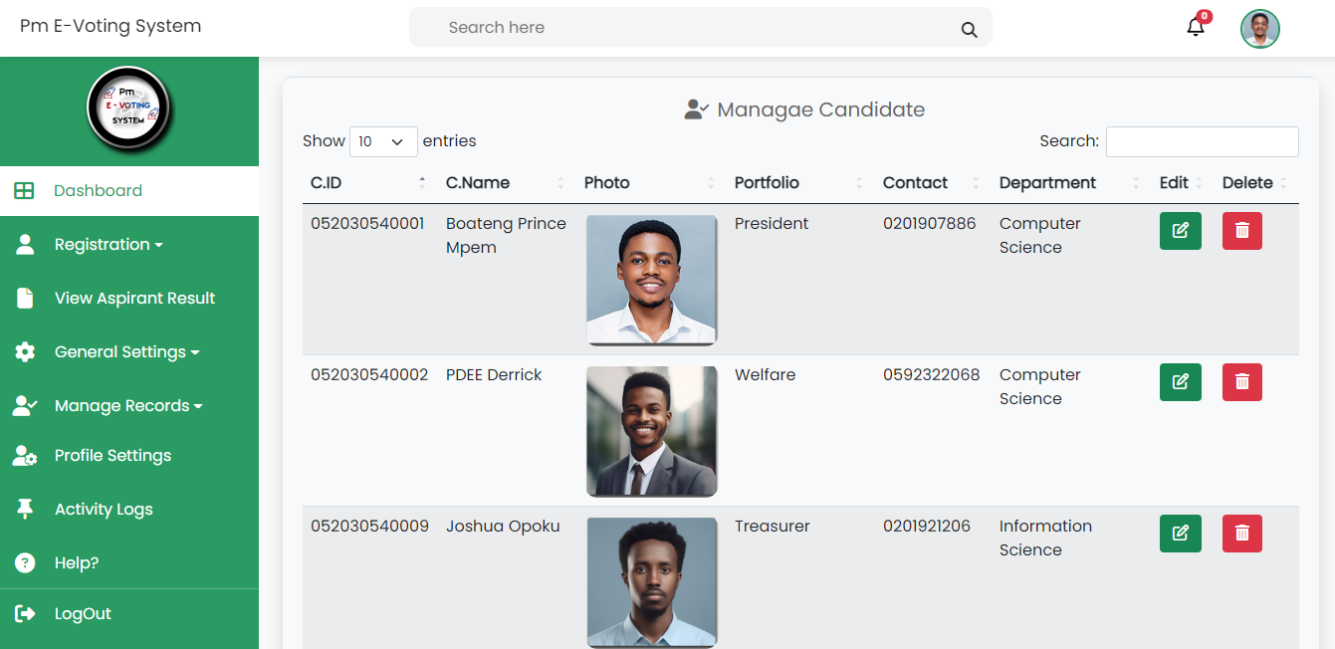

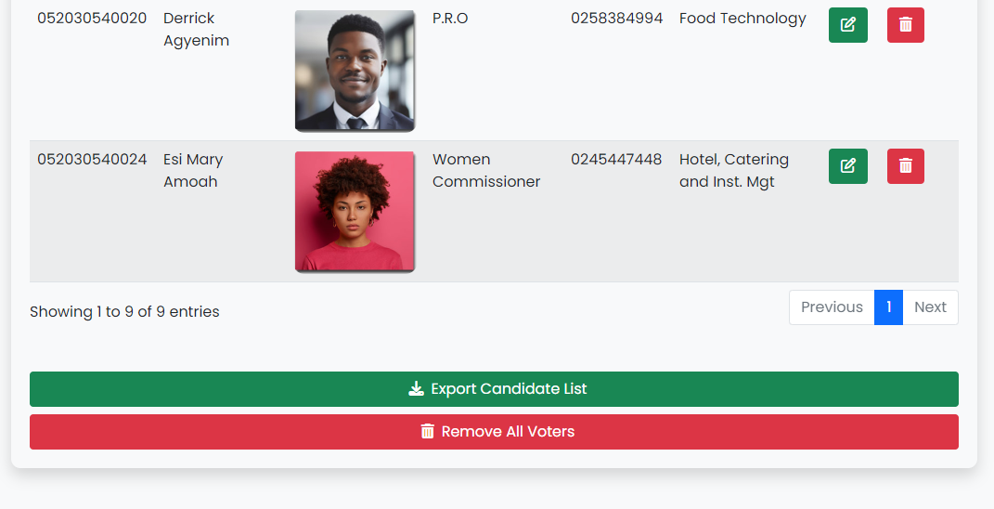

Figure 27 Candidate Management Interface

**11. Manage Polling Officer Interface**

The Manage Polling Officer Interface empowers the Electoral Commission (EC) to efficiently oversee and communicate with polling agents. Within this interface, the EC can delete individual polling agent records, export the entire list of polling agents as needed, or truncate the list entirely. Furthermore, the interface facilitates communication by enabling the EC to send general messages to all polling agents and address reported issues promptly. This comprehensive tool enhances the management and coordination of polling officers during electoral events.

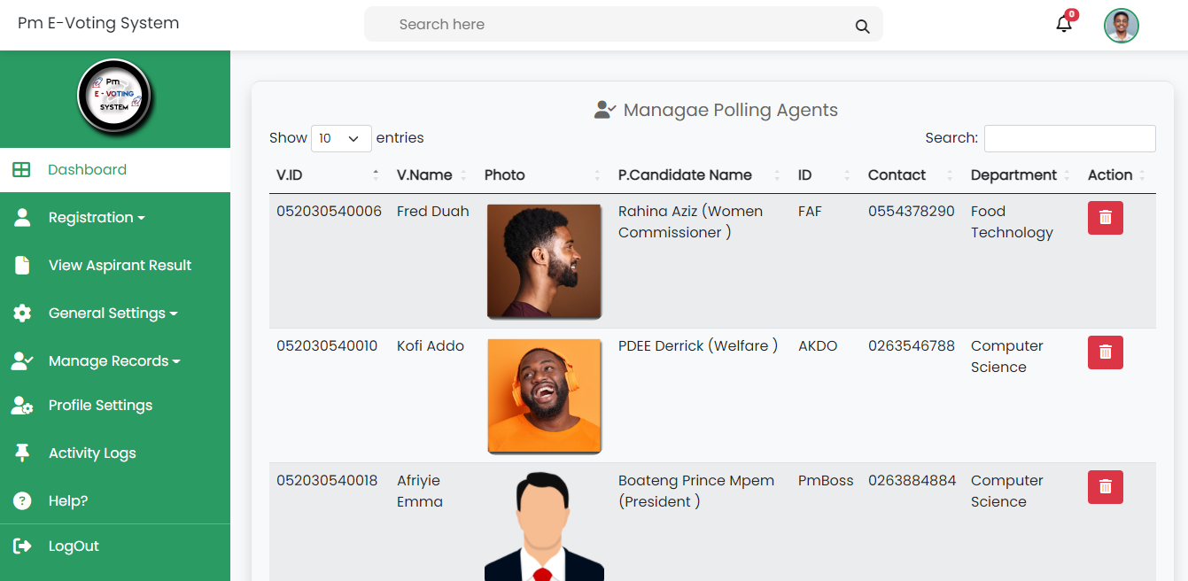

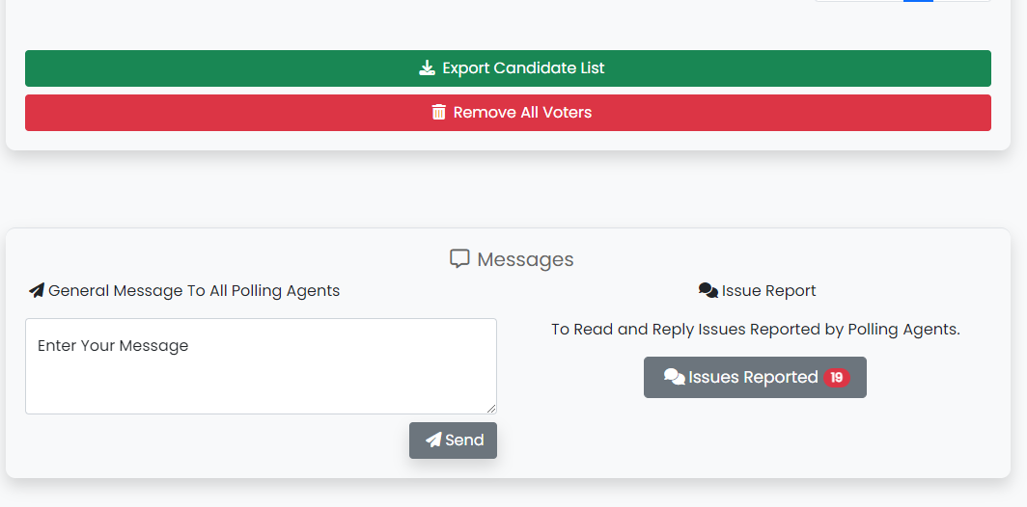

Figure 28 Polling Agent Management Interface

**12. Profile Settings Interface**

The Profile Settings Interface provides EC with the ability to update their profiles conveniently. EC can set a new password for enhanced security and update their profile photo to personalize their account. This user-friendly interface ensures that individuals can manage their profiles with ease and maintain the accuracy and security of their accounts.

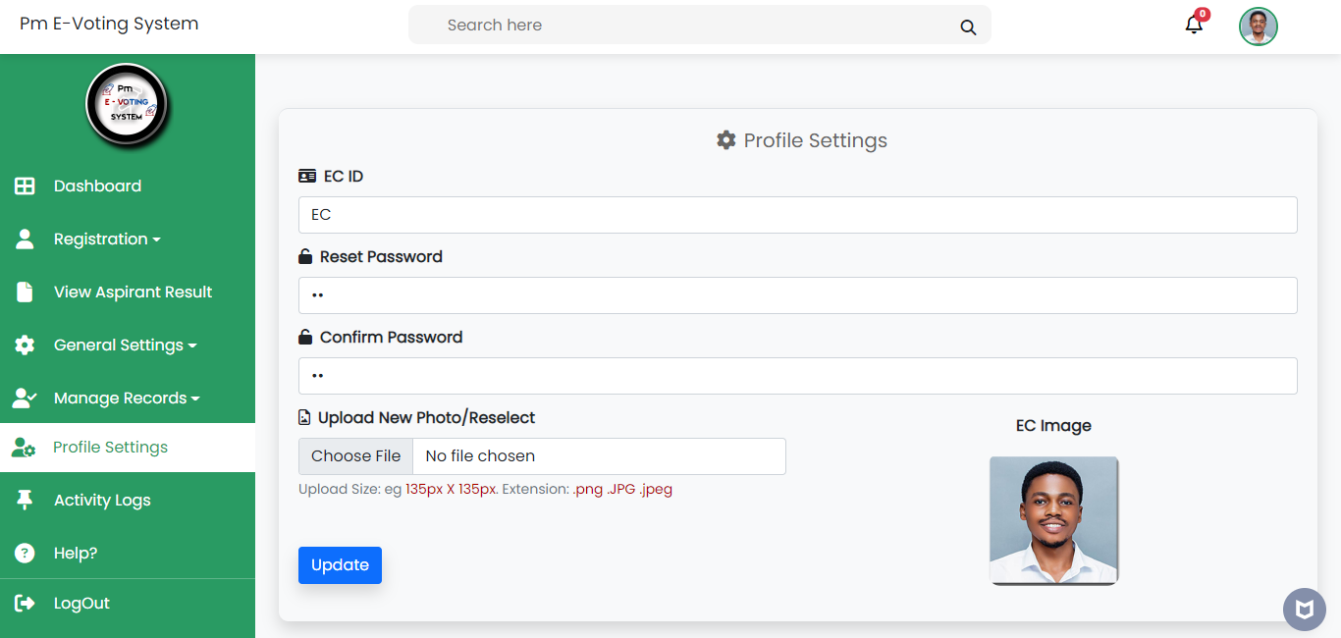

Figure 29 EC Profile Settings Interface

**13. EC Activity Logs Interface**

The EC Activity Logs Interface displays essential information, including the EC ID, activity logs, IP address, and date and time, providing a comprehensive record of actions and interactions within the electoral system. This log ensures transparency and accountability in EC operations.

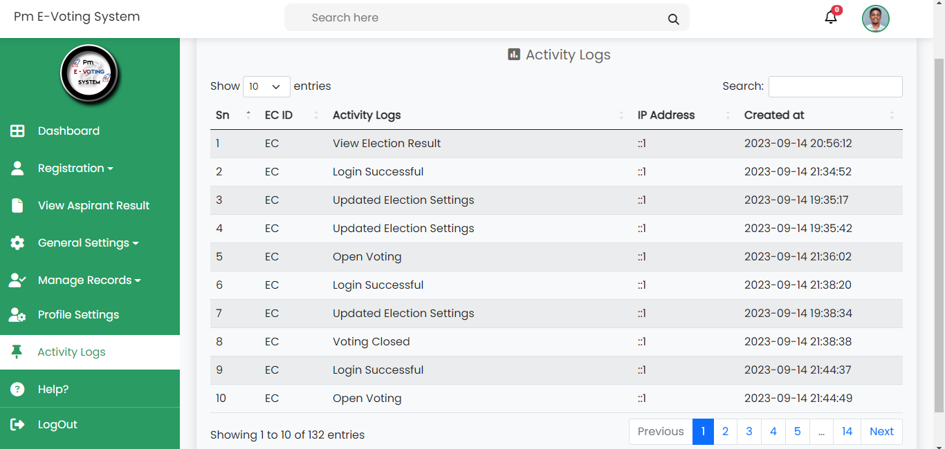

Figure 30 EC Activity Logs Interface

**14. Help Interface**

The EC Help Interface is a one-stop resource for Electoral Commission (EC) members, offering essential information, FAQs, and a platform to seek clarification on any uncertainties. It ensures efficient EC operations with readily available assistance.

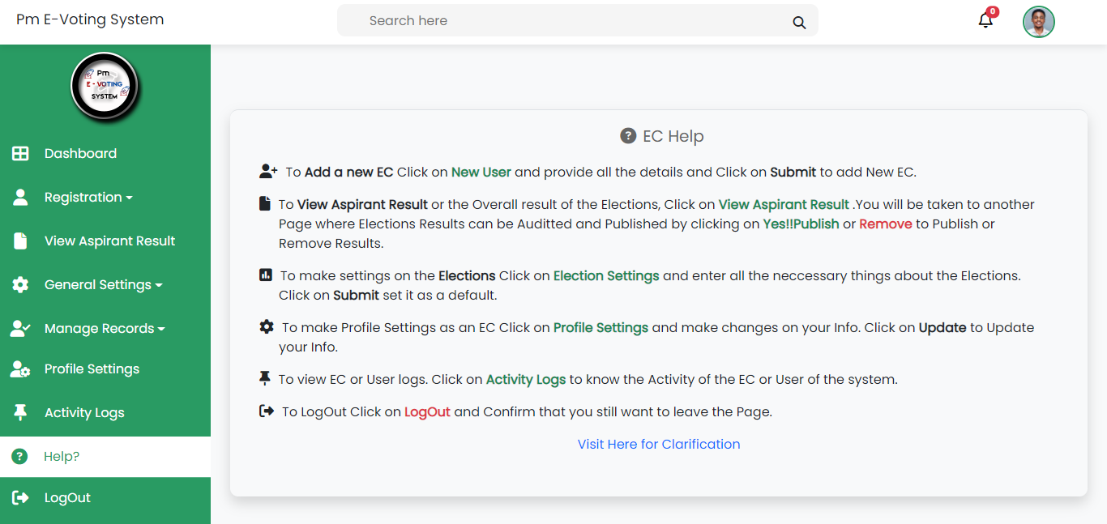

Figure 31 EC Help Interface

#### **4.3.4 Polling Officer**

**1. Polling Officer Login Interface**

The Polling Officer Login Interface requires polling officers to enter their unique Polling Agent ID and password for secure access to the electoral system. This straightforward login process ensures the integrity of polling officer interactions within the platform.

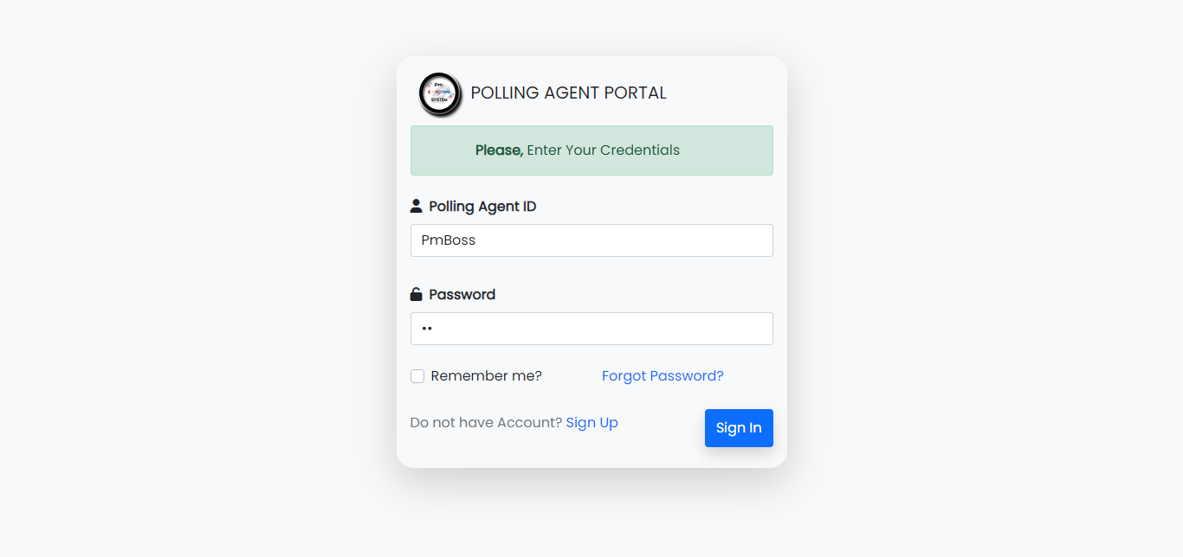

Figure 32 Polling Agent Login Interface

**2. Dashboard Interface**

The Dashboard Interface serves as a centralized platform displaying essential polling agent rules, regulations, and guidelines. It provides easy access to crucial information, ensuring that polling agents are well-informed and can perform their duties effectively in accordance with electoral protocols.

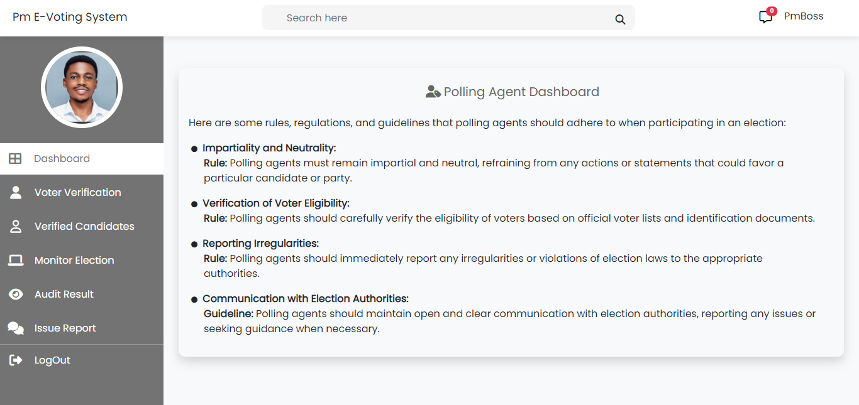

Figure 33 Polling Agent Dashboard Interface

**3. Voter Verification Interface**

The Voter Verification Interface presents a comprehensive list of voters along with their voting status, indicating whether they have cast their votes or not. This straightforward interface provides real-time updates on voter participation, aiding in the monitoring and verification of the electoral process.

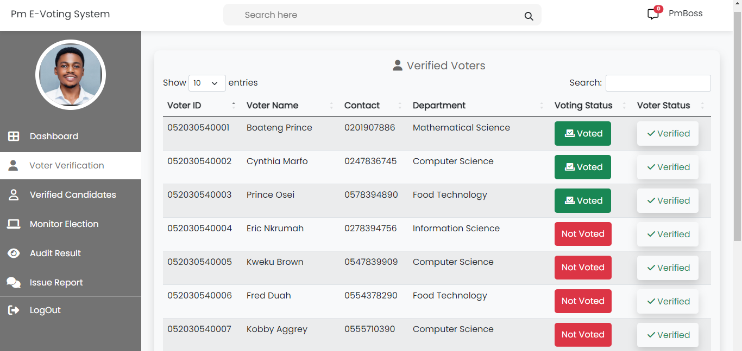

Figure 34 Voter Verification Interface

**4. Candidate Verification Interface**

The Candidate Verification Interface displays a complete list of candidates and their verification status, indicating whether they have been verified or not. This user-friendly interface simplifies the monitoring and confirmation of candidate eligibility within the electoral system.

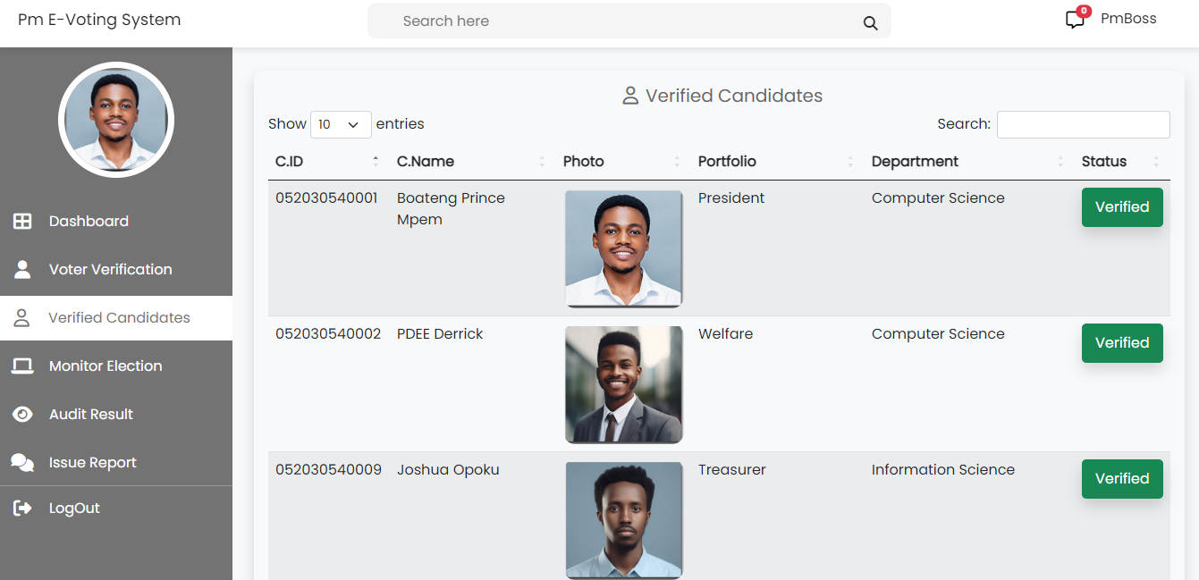

Figure 35 Candidate Verification Interface

**5. Monitor Election Interface**

The Monitor Election Interface offers real-time election data, including the total number of voters, votes cast, and a continuously updated list of candidates with their corresponding results as the election progresses. This dynamic interface provides immediate insights into the evolving electoral landscape, enhancing transparency and awareness during the election process.

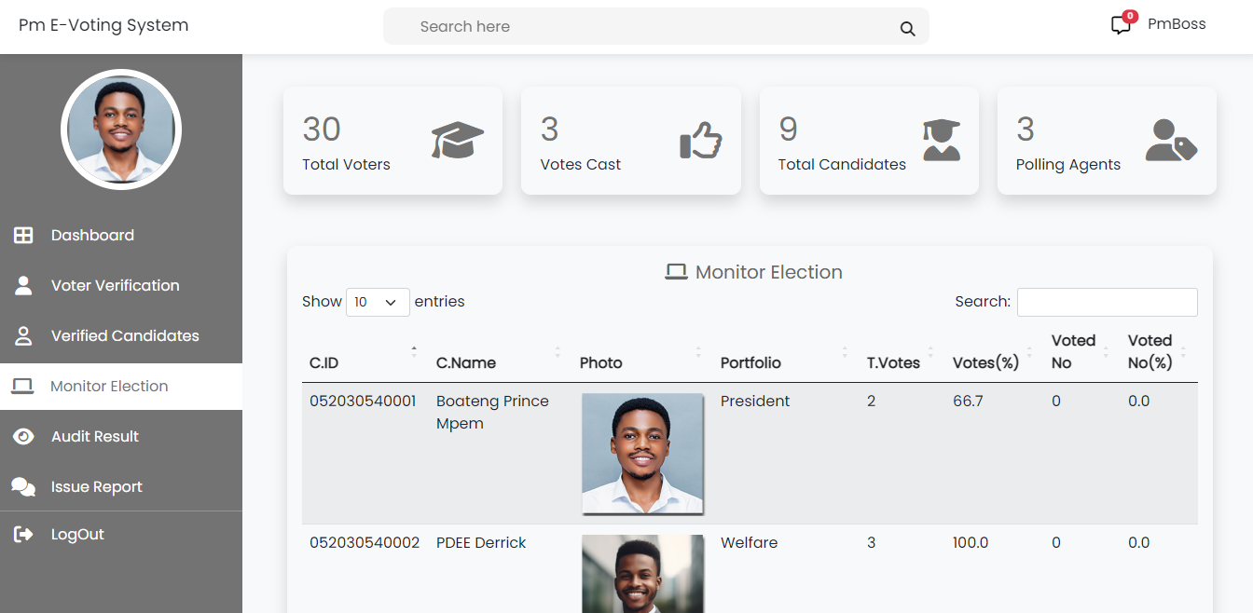

Figure 36 Polling Agent Monitor Election interface

**6. Audit Election Interface**

The Audit Election Interface presents the election results for polling agents to audit, verifying the accuracy and fairness of the electoral outcome. This interface plays a crucial role in upholding transparency and electoral integrity.

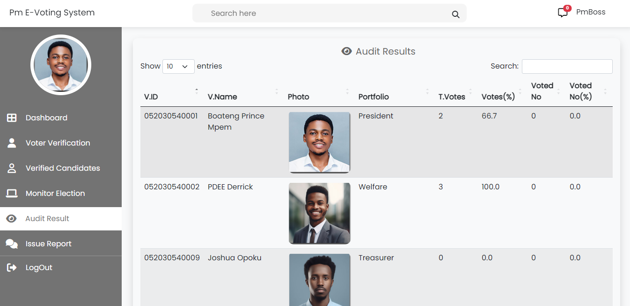

Figure 37 Polling Agent Audit Election Interface

**7. Issue Report Interface**

The Issue Report Interface connects polling officers with online Electoral Commission (EC) members for real-time chat, allowing polling officers to report issues directly to the EC. This feature facilitates immediate communication and issue resolution, ensuring smooth electoral operations.

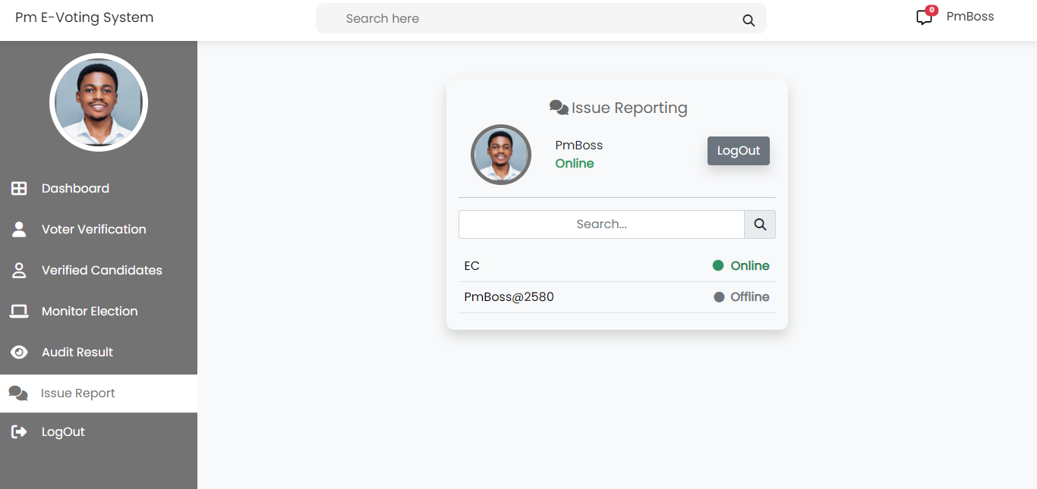

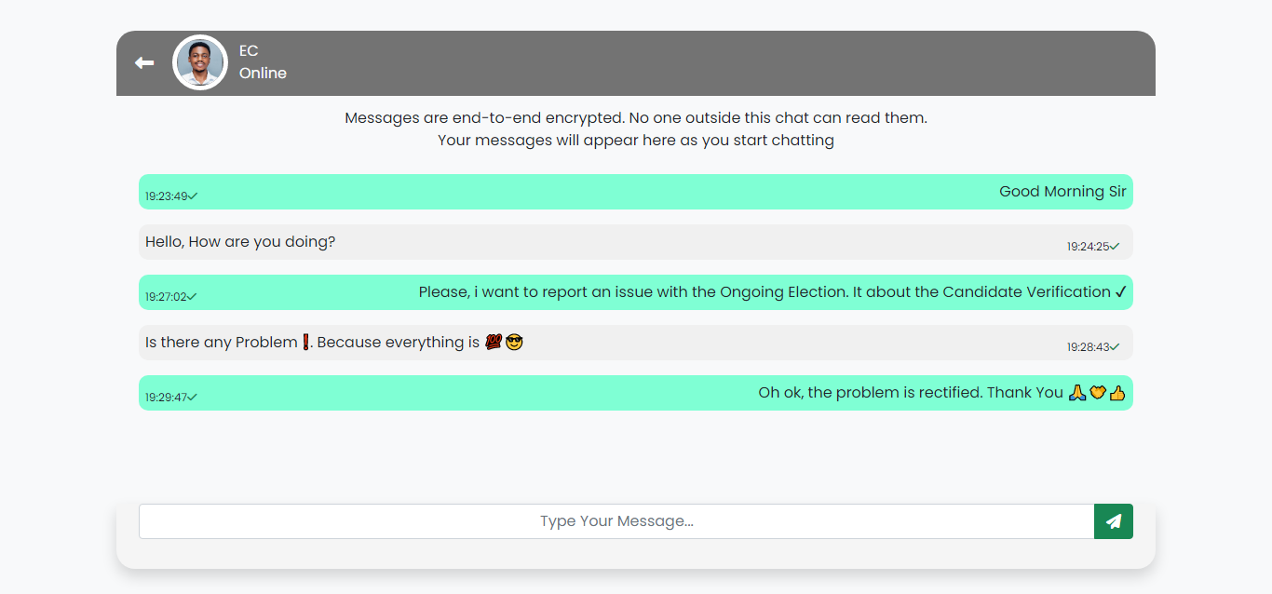

Figure 38 Polling Agent Issue Report with Chat Room Interface

### **4.4 Software Testing**

Software testing is the process of verifying and validating whether a software or application is defect-free, meets the technical and user requirement effectively and efficiently in order to produce quality product. Software testing can be divided into two steps namely; verification and validation. Verification refers to a set which ensures that the software correctly performs a specific function. Validation refers to the different set of tasks that ensure that software being built meets the user’s requirements and purpose. Software testing can be classified into four major levels. They include; unit testing, integration testing, system testing, acceptance testing. Software testing is very relevant tool for developers due to the following reasons;

* It helps to test and improve the quality of the software or program.
* It ensure customer satisfaction and fulfilment in the software.
* It is required for the effective performance of the program.

**1. Unit Testing**

Unit testing is a type of software testing where individual units or groups of related units of a software are tested. It is a testing method using which every independent component is tested to determine if there is a defect on the software. Independent components are referred to as individual functions or procedure. Unit testing is mostly done by developers to verify the correctness of the software.

**2. Integration Testing**

Integration testing is a type of software testing whereby group of individual components are combined to produce an output. Its main purpose is to take unit-tested components and build a program structure with specified functional requirements. That is, it takes input modules that have been unit tested, groups them into large aggregates, applies tests defined in an integration test plan to those aggregates, and delivers its output to the integrated system ready for system testing.

**3. System Testing**

After the integration testing, the system testing validates the complete and fully integrated software product. System testing consists of a series of different tests with the purpose of validating the full computer-based system. This ensures an end- to-end system specification.

**4. Acceptance Testing**

After system testing, acceptance testing is done with the customers' data to check that the system meets the customers' needs. That is, it evaluates the compliance of the system with the customers' requirements and assess whether the system is acceptable and ready for deployment.

**5. Test Cases**

A test case is a set of actions that execute to verify a particular feature or functionality of the system. It is to determine whether the various features of the system are operating as expected as well as confirming whether it meets the user's requirement. Table 1.1: shows sample of Test cases on Admin login form. And Table 1.2: shows sample of Test cases on Admin login form The objective is to check whether the entered Credentials are valid or invalid.

**Table 1.1 Test Case for Electoral Commissioner**

|  |  |  |  |  |  |  |
| --- | --- | --- | --- | --- | --- | --- |
| **Test Case ID** | **Test Case** | **Test Steps** | **Test Data** | **Expected Result** | **Actual Result** | **Status** |
| TC-LOO1 | Check Login functionality with valid EC ID and valid Password | Enter EC ID and Password, click on login button | EC ID = “**EC**”  Password=’**12**’’ | Login Successfully. Should navigate to Admin page. | Login Successfully. Display EC page | Approved |
| TC-LOO2 | Check Login functionality with valid EC ID and invalid Password | Enter EC ID and Password, click on login button | EC ID =’’  **EC**’’  Password=’’**Boat258**’’ | Should display Invalid or Incorrect Credentials | Error message box “Invalid Credentials” | Unapproved |
| TC-LOO3 | Check Login functionality with invalid EC ID and valid Password | Enter EC ID and Password, click on login button | EC ID =’’  **EC**’’  Password=’’**Boat2580**’’ | Should display “Invalid or Incorrect Credentials” | Error message box “Invalid Credentials” | Unapproved |
| TC-LOO4 | Check Login functionality with invalid EC ID and invalid Password | Enter EC ID and Password, click on login button | EC ID =’’**EC**’’  Password=’’**Boat256**’’ | Should display “Invalid or Incorrect Credentials” | Error message box “Invalid Credentials” | Unapproved |
| TC-LOO5 | Check Login functionality with empty textbox EC ID and empty textbox Password | Enter blank EC ID and blank Password, click on login button | EC ID =’’  ’’  Password=’’ ’’ | Should display a message box “Please complete the field” | Prompt message “Please complete the field” | Unapproved |

**Table 1.2 Test Case for Voters**

|  |  |  |  |  |  |  |
| --- | --- | --- | --- | --- | --- | --- |
| **Test Case ID** | **Test Case** | **Test Steps** | **Test Data** | **Expected Result** | **Actual Result** | **Status** |
| TC-LO11 | Check Login functionality with valid Voter ID and valid Serial Code | Enter Voter ID and Serial code, click on login button | Voter ID = “**0520305400035**”  Serial Code=’’ **b21i3o”** | Login Successfully. Should navigate to Voting page or View results Page. | Login Successfully. Display Voting page or View results Page. | Approved |
| TC-LO22 | Check Login functionality with valid Voter ID and invalid Serial Code | Enter Voter ID and Serial code, click on login button | Voter ID =’’  **0520305400035**’’  Serial Code=’’**b2iu8p**’’ | Should display Invalid or Incorrect Credentials | Error message box “Invalid Credentials” | Unapproved |
| TC-LO33 | Check Login functionality with invalid Voter ID and valid Serial Code | Enter Voter ID and Serial code, click on login button | Voter ID =’’  **0520305400002**’’  Serial Code=’’ **b21i3o**’’ | Should display “Invalid or Incorrect Credentials” | Error message box “Invalid Credentials” | Unapproved |
| TC-LO44 | Check Login functionality with invalid Voter ID and invalid Serial Code | Enter Voter ID and Serial Code, click on login button | Voter ID =’’  **052030540035**’’  Serial Code=’’**b2iu8p**’’ | Should display “Invalid or Incorrect Credentials” | Error message box “Invalid Credentials” | Unapproved |
| TC-LO55 | Check Login functionality with empty textbox Voter ID and empty textbox Serial Code | Enter blank Voter ID and blank Serial Code, click on login button | Voter ID =’’ ’’  Serial Code=’’ ’’ | Should display a message box “Please complete the field” | Prompt message “Please complete the field” | Unapproved |

#### **4.4.1 Error Message of the System**

The error message are concise notification informing users about unexpected issues that occurs during program execution.

**Login Error Message**

The Login Error Message is displayed when a user, whether it's a Voter, EC member, or Polling Officer, attempts to log in with incorrect or invalid credentials. This message informs users that their login attempt was unsuccessful due to incorrect information provided and prompts them to re-enter their credentials for access.

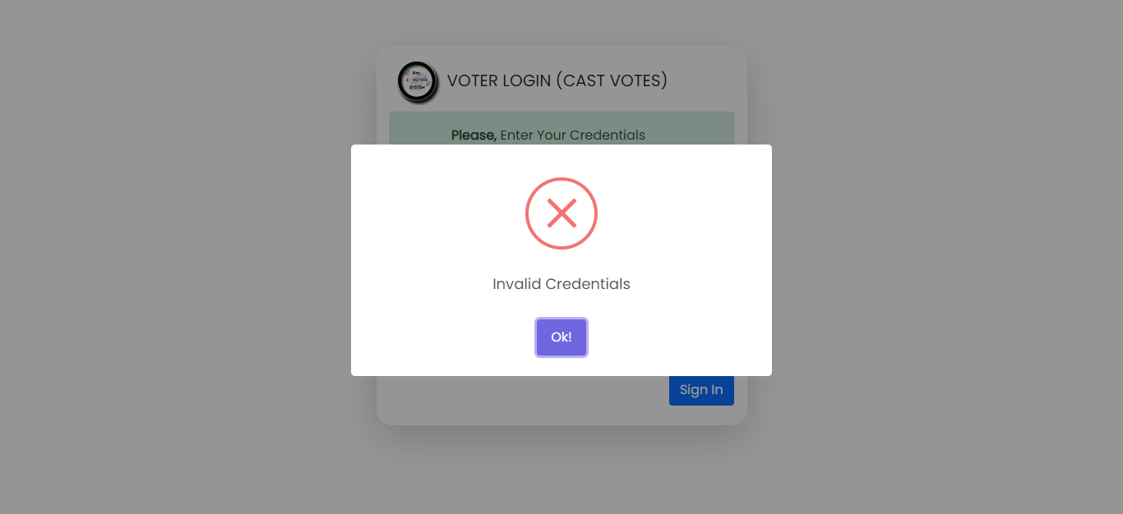

Figure 39 Login Error Message

**EC Registration Error Message**

The EC Registration Error Message appears when an Electoral Commission (EC) member attempts to register but is already registered in the system. It advises the user to use their existing account or contact support for assistance.

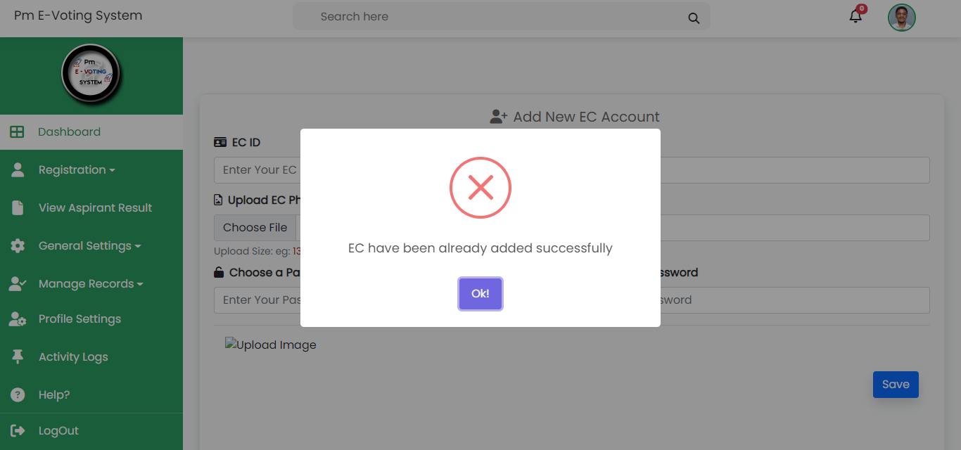

Figure 40 EC Registration Error Message

**Voter Registration Error Message**

The Voter Registration Error Message occurs when a voter with a specific ID is already registered in the system. It informs the user that registration with the provided ID already exists and provides guidance on next steps or contacting support if needed.

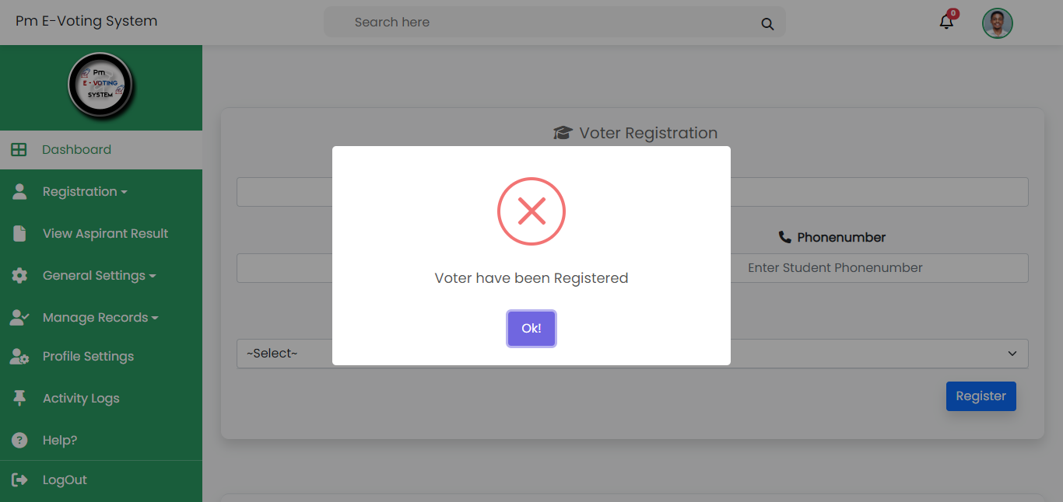

Figure 41 Voter Registration Error Message

**Candidate Registration Error Message**

The Candidate Registration Error Message is displayed when a voter with a particular ID is already registered as a candidate. It alerts the user that their candidate registration cannot proceed as the provided ID is already associated with a candidate profile. Users may be directed to contact support or take appropriate action accordingly.

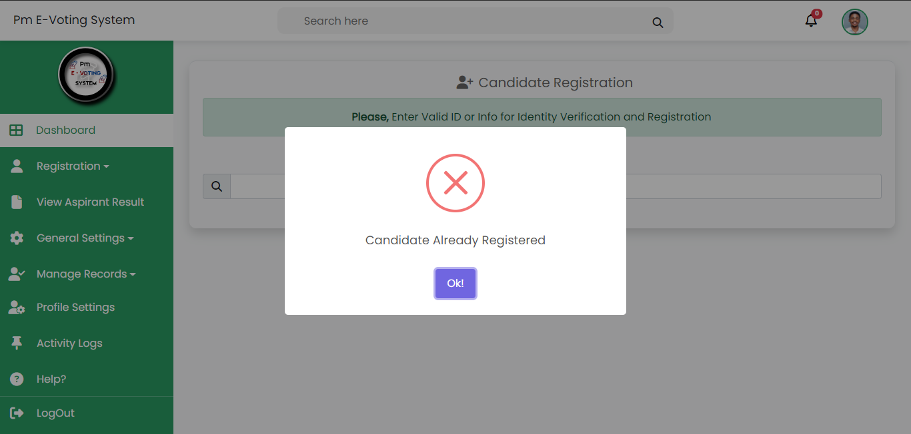

Figure 42 Candidate Registration Error Message

**Portfolio Registration Error Message**

The Portfolio Registration Error Message appears when a portfolio name is already registered in the system. It informs the user that the chosen portfolio name is already in use and suggests selecting an alternative name or contacting support for assistance.

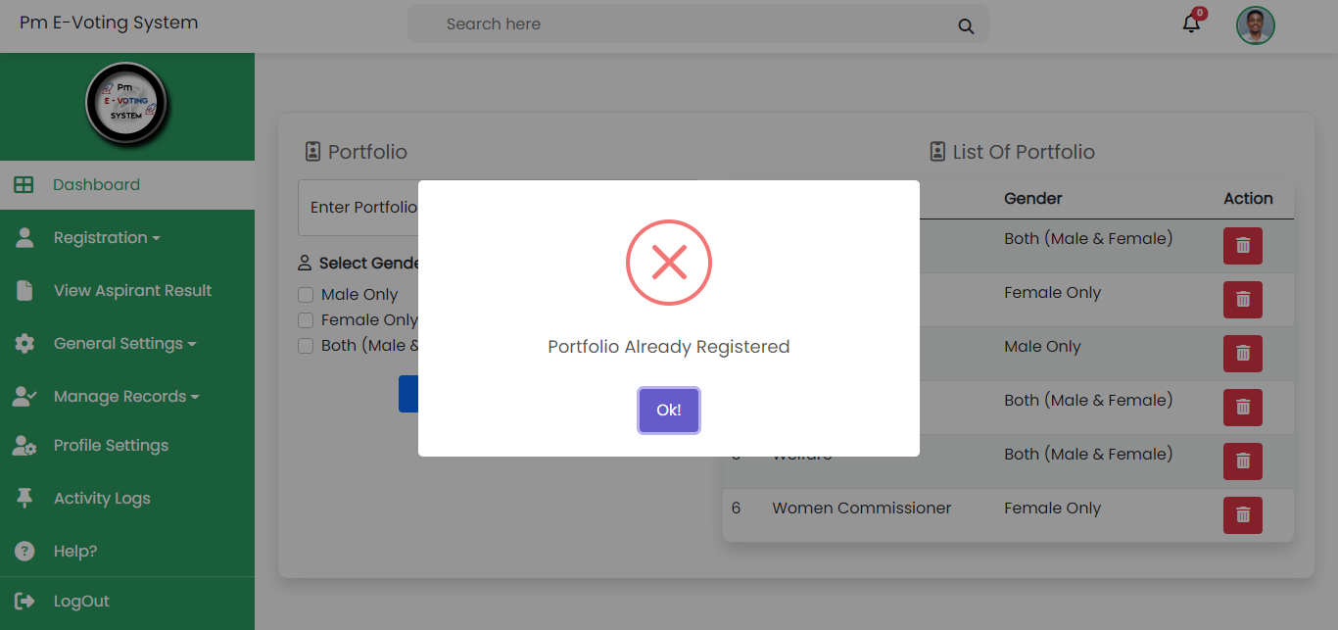

Figure 43 Portfolio Registration Error Message

**Department Registration Error Message**

The Department Registration Error Message is displayed when a department name that the user is attempting to register already exists or is already registered in the system. It advises the user that the chosen department name is already in use and provides guidance on selecting a different name or contacting support for assistance.

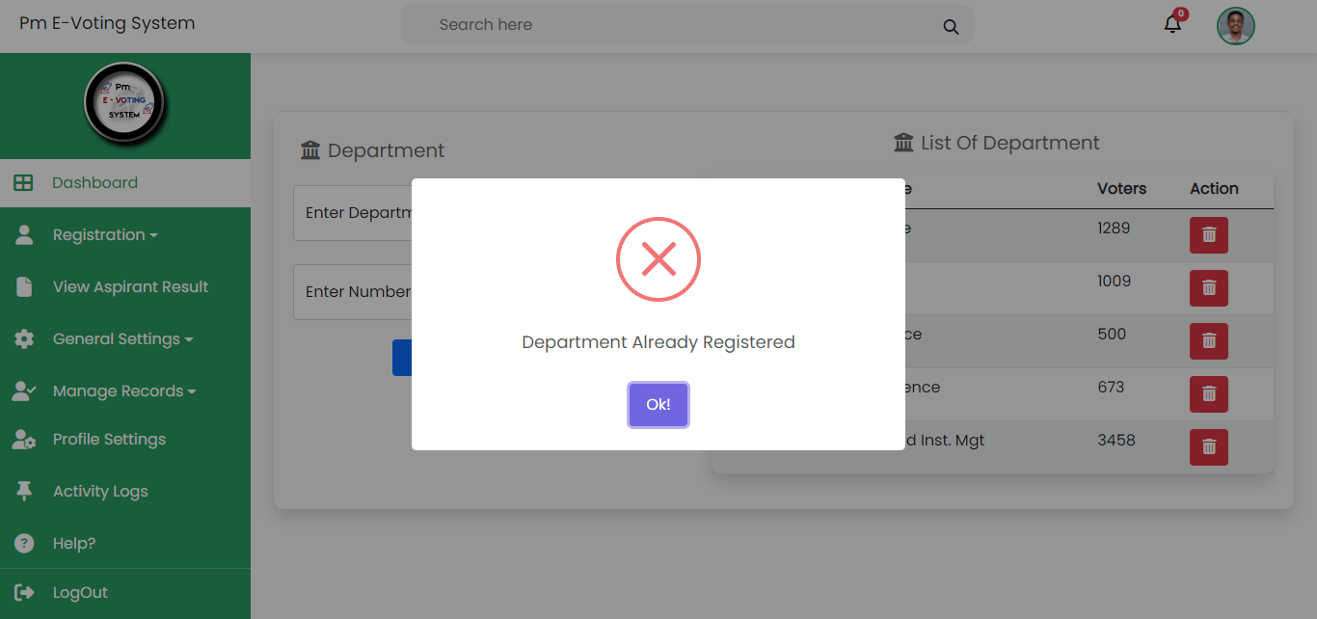

Figure 44 Department Registration Error Message

**SMS Error Message**

The SMS Error Message occurs when an SMS containing a voter's credentials (voter ID and serial) fails to deliver to the intended voter's number. It informs the sender that voter is not validate because SMS transmission was unsuccessful, and it may suggest checking the recipient's number or retrying the SMS.

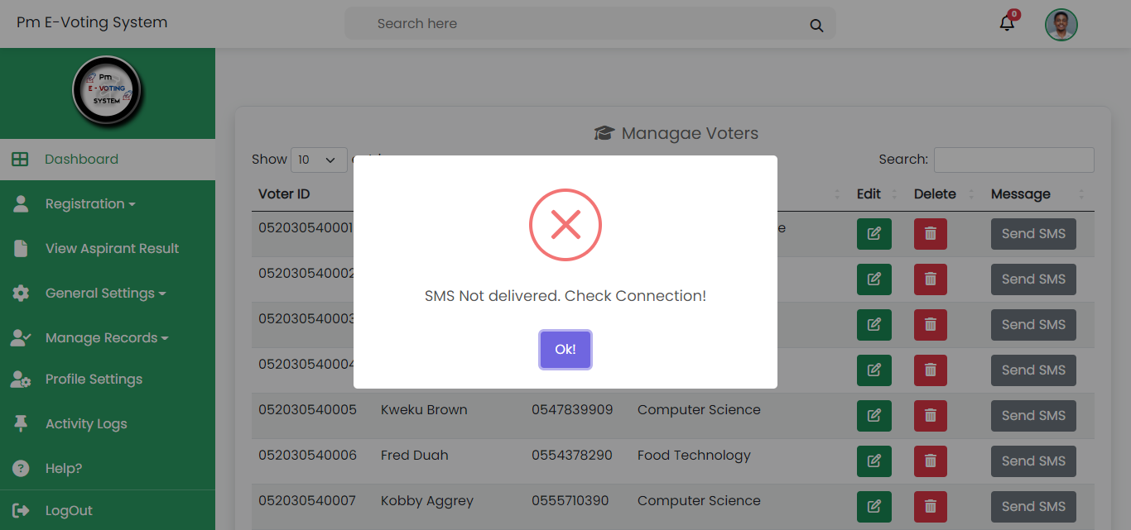

Figure 45 SMS Error Message

**Password Error Message**

The Password Error Message is triggered when a password entered by a polling agent during registration or profile update does not match the required criteria or the confirmation password. It prompts the user to re-enter the password accurately and ensure it matches the specified criteria for security purposes. 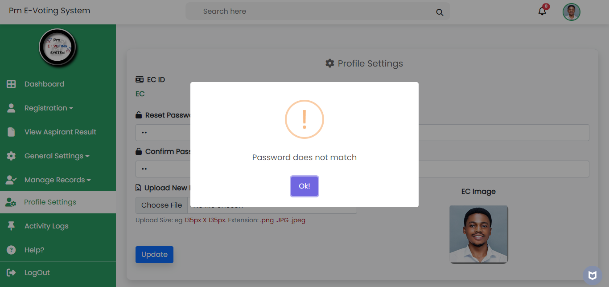

Figure 46 Password Does Not Match Error Message

**Polling Agent Registration Error Message**

The Polling Agent Registration Error Message is displayed when a polling agent is already assigned to a candidate and an attempt is made to register them again for the same role. It informs the user that the polling agent is already assigned and suggests contacting support or verifying their assignment before proceeding with registration.

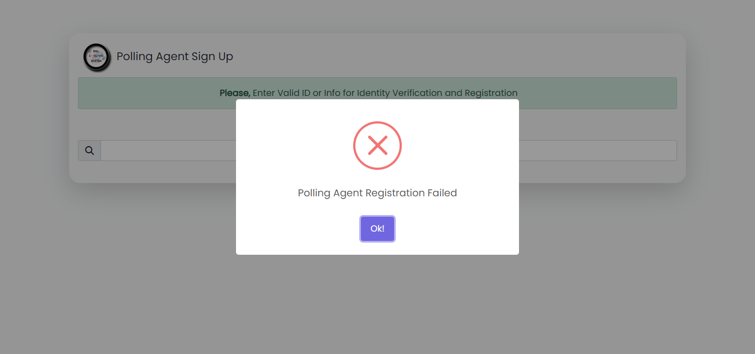

Figure 47 Polling Agent Registration Error Message

**Voting Error Message**

The Voting Error Message is displayed when a voter attempts to vote again after already casting their ballot. It informs the voter that their vote has already been recorded and advises against attempting to vote more than once to maintain the integrity of the electoral process.

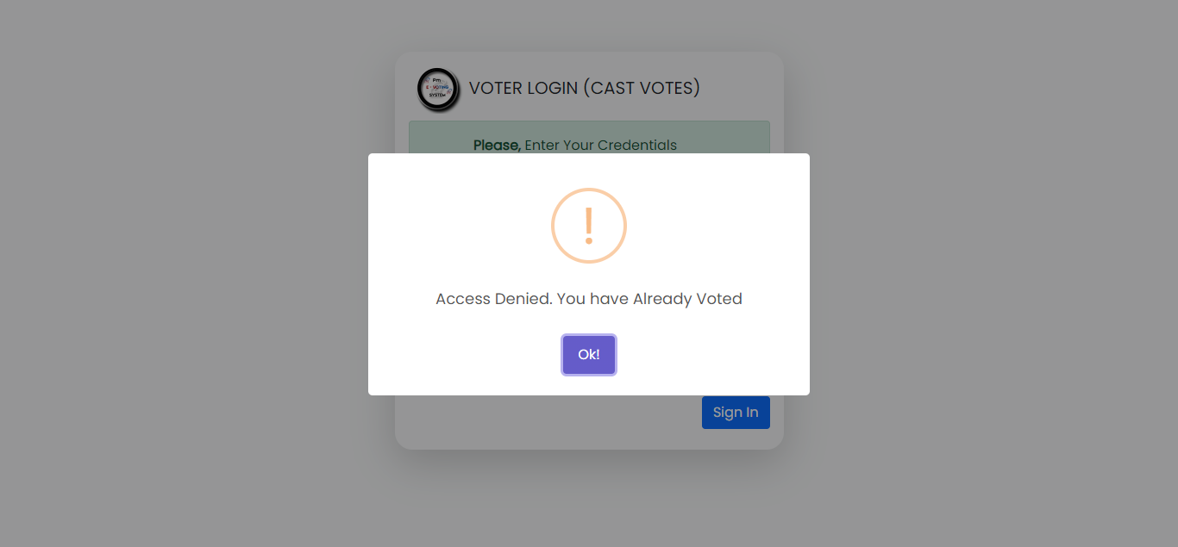

Figure 48 Voting Error Message

**Required Field Error**

The Required Field Error occurs when a checkbox is not checked before submitting a form or pressing a button that requires the checkbox to be selected. It reminds the user to check the required checkbox before proceeding with the action, ensuring that necessary information or consent is provided.

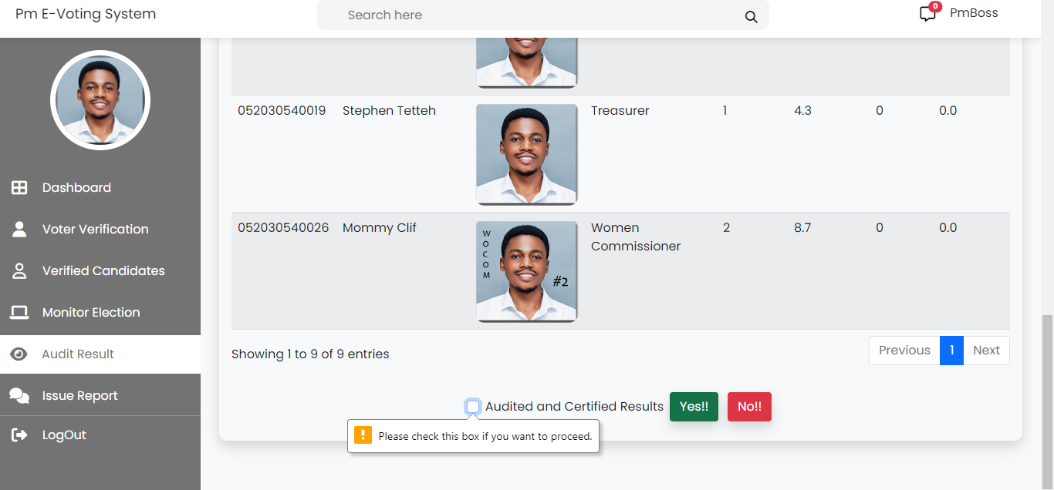

Figure 49 Required Field Error

# **CHAPTER FIVE**

# **SUMMARY, CONCLUSION AND FUTURE WORK**

The objective of this chapter is to summarize the overall work. Furthering with a discussion telling whether the objectives stated in chapter one has been achieved and how were they achieved during the project work. Analysis of the implemented system, listing its strengths and limitations. The chapter concluded with future works expected to be implemented.

### **5.1 Summary of Work**

This project is an e-voting system with online upload of results. The voting system is designed with PHP and HTML where all use a remote database. By logging in as an Electoral Commissioner with valid Credentials (EC ID and Password), the system enables the Electoral Commissioner to manage candidates by registering, Search for Candidate Information, updating and deleting Candidate information. The system also enables Electoral Commissioners to manage voters by registering, searching for voter’s information, updating, deleting voters’ information, import and export CSV of the voters’ information, and view all the information about all the registered voters. This system also gives the Electoral Commissioner the ability to send the voter’s Credentials for logging in including serial code as SMS to the voter’s Phone number. The Electoral Commissioner also have the tendency to open voting according to the time and also close voting when the time for voting is over.

By entering valid Electoral Commissioner credentials. This enables the Electoral Commissioner to register new EC, Upload results after audit, view all registered voters, update profile, and view activity logs. Voters can also view overall election results by entering valid credentials (Voter ID and Serial Code), updating election details, and clicking on the link that was sent via phone number.

Voters receive login credentials via their phone numbers, use them to cast their votes, and can later access election results once the voting period ends, promoting transparency and participation in the electoral process.

Polling officers or agents play a crucial role in the electoral process. They verify both candidates and voters to ensure eligibility, monitor the election proceedings to maintain fairness and order, and audit election results after the voting period ends to verify accuracy. Additionally, they serve as a vital link in reporting any issues or irregularities to the Electoral Commission, contributing to the integrity of the elections.

### **5.2 Discussion**

In the project "E-voting System with Online Upload of Results," the objectives outlined are focused on creating a secure and efficient electronic voting system. Discussion on each objective and how they were likely achieved during the project work.

**Objective 1: To register eligible voters electronically**

**Approach:** The project likely involved the development of a user-friendly interface that allows election administrators (EC) to register voters electronically. This includes two methods: importing a CSV file containing voter information for bulk registration and individual registration when dealing with a smaller number of voters. The system's backend have been designed to handle both methods seamlessly.

**Achievement:** The achievement of this objective is seen to be successfully implemented on the registration process. The system is capable of securely storing voter information in a database, whether it's imported in bulk from a CSV file or registered individually. Data security measures like encryption and access controls would likely be put in place to protect voter information.

**Objective 2: To authenticate voters and send serial codes via SMS**

**Approach:** The system would generate a serial code for each registered voter after a successful registration. It would then integrate with an SMS gateway to send this serial code along with the voter's ID to the valid contact provided during registration. Additionally, a process for recovering credentials would be implemented, involving the use of a one-time password (OTP) sent to the voter's contact.

**Achievement:** This objective's achievement would be demonstrated by the successful integration of the SMS gateway and the secure handling of serial codes and OTPs. It ensures that only valid voters with accurate contact information can authenticate themselves, preventing unauthorized access.

**Objective 3: To enable one-to-one votes**

**Approach:** The voting system is designed to allow each registered voter to cast a single vote in the relevant election. This likely involves creating a unique identifier for each voter and ensuring that the system allows only one vote per identifier.

**Achievement:** Achieving this objective means that the system can accurately track and restrict each voter to casting only one vote. This is crucial for maintaining the integrity of the voting process.

**Objective 4: To cumulate casted votes and provide results after voting time**

**Approach:** The system would be designed to record and tally the votes cast by voters during the voting period. Once the voting time expires, the system would calculate the results based on the accumulated votes and make them available to publish.

**Achievement:** The achievement of this objective would be evident in the accurate calculation and display of voting results after the voting period concludes. The system should ensure that the results are kept confidential until the designated time.

**Objective 5: To set a valid voting period**

**Approach:** The system would have a mechanism for setting and enforcing a specific voting period. This likely involves configuring start and end times for the voting process and preventing any voting activities outside of this window.

**Achievement:** Achieving this objective would involve the successful implementation of a time-bound voting system. The system should prevent any voting before the start time and after the end time.

### **5.4 Analysis of the Implemented System**

#### **5.4.1 Strength and Limitation**

The Strength of the project determines how the system is designed. The strength of the system is as follows;

* Simplicity
* Reduced Complexity
* User Friendly
* Privacy Enhancement

The limitation of the project can be the constraint that imposes certain boundaries or prevents something from reaching the project full potential. This limitation are as follows;

* Accountability and Transparency
* Security
* Trust Issues
* Legal and Regulation Compliance

### **5.3 Conclusion**

In conclusion, the "E-voting System with Online Upload of Results" presents a dynamic approach to modernizing the electoral process. Its user-friendly interface and exclusion of numbering offer simplicity and potentially encourage greater voter engagement, streamlining the voting experience. However, this approach also raises concerns about vote authenticity, transparency, and accountability. Balancing the benefits of user-friendliness with the necessity for accurate result compilation and secure vote management will be crucial for the system's success. As technology continues to reshape electoral practices, addressing the limitations while harnessing the strengths of this system will be essential in shaping the future of democratic participation.

### **5.4 Future Work**

The "E-voting System with Online Upload of Results" holds promising avenues for future development. Strengthening security through advanced cyber security measures, multi-factor authentication, and potential blockchain integration should be a priority, enhancing data protection and user trust. Usability can be optimized via comprehensive testing, ensuring a user-friendly experience for all participants. Robust auditing mechanisms and legal compliance measures would bolster accountability and regulatory adherence. Public education campaigns can foster transparency and trust-building, while consistent updates will ensure the system remains current and resilient against emerging challenges. Through these efforts, the system can evolve into a secure, accessible, and reliable platform that enhances the electoral process in an increasingly digital landscape.

# **REFERENCES**

[1] Alvarez, R. M., & Hall, T. E. (2008). Electronic Elections: The Perils and Promises of Digital Democracy. Princeton University Press.

[2] Camp, L. J. (2018). Voting Machines: History, Requirements, and Challenges. Encyclopedia of Cryptography and Security, 1-11.

[3] Krimmer, R., & Volkamer, M. (Eds.). (2012). Electronic Voting. Springer.

[4] Trechsel, A. H., & König, T. (2012). Electronic Voting and Democracy: A Comparative Analysis. Palgrave Macmillan.

[5] Sebesta, R. W. (2016). Concepts of Programming Languages. Pearson.

[6] OpaVote. (Accessed on [Date]). [URL]

[7] Smith, J., & Johnson, A. (Year). "Ensuring Security in Online Voting Platforms." Journal of Cybersecurity, 10(2), 123-138.

[8] Brown, M. (Year). "User Interface Design for Online Voting Systems." International Conference on Human-Computer Interaction, 45-53.

[9] Williams, R., & Lee, S. (Year). "Advantages of Ranked-Choice Voting in Election Platforms." Proceedings of the Annual Conference on Electronic Voting, 78-85.

[10] Johnson, A., et al. (Year). "Improving Voter Participation through Automated Reminders." Journal of E-Government Studies, 22(3), 187-198.

[11] Gupta, S., & Sharma, P. (Year). "Real-Time Results Reporting in Online Voting Systems." International Conference on E-Democracy, 195-203.

[12] Miller, L., et al. (Year). "Optimizing Voter Engagement with Waitlist Management." Proceedings of the Annual Symposium on Internet Voting, 112-119.

[13] Lee, K., & Kim, C. (Year). "Challenges of Internet Dependency in Online Voting Platforms." Journal of Internet Research, 30(4), 256-267.

[14] Jones, D., & Smith, P. (Year). "Addressing Data Privacy Concerns in Online Voting Systems." Cybersecurity Journal, 15(1), 42-55.

[15] Wang, Q., et al. (Year). "Offline Voting Options for Limited Internet Access in Online Voting Platforms." Proceedings of the International Conference on E-Government, 75-82.

[16] ElectionBuddy. (Accessed on [Date]). [URL]

[17] Borowiec, A., & Lewandowski, A. (2015). E-voting systems and their features. International Journal of Engineering and Innovative Technology (IJEIT), 4(7), 250-256.

[18] Dimitrakakis, C., & Samaras, N. (2018). Blockchain technology in e-voting: Benefits and challenges. In 2018 International Conference on Information Networking (ICOIN) (pp. 423-428). IEEE.

[19] Krimmer, R., & Volkamer, M. (2013). Electronic voting: Second International Joint Conference, E-Vote-ID 2013, Proceedings. Springer.

[20] Marky, K., Marky, I., Marky, M., & Marky, J. (2021). E-voting advantages and challenges. In Proceedings of the International Conference on Advanced Computer Science and Information Systems (pp. 186-194). Springer.

[21] Smith, A. D. (2009). E-voting and the UK 2010 general election: a mess or a triumph? Representation, 45(3), 269-279. [14] Tambouris, E., Macintosh, A., & Smithson, S. (Eds.). (2012). Electronic participation: Third IFIP WG 8.5 International Conference, ePart 2011, Proceedings. Springer.

[22] Tambouris, E., Macintosh, A., & Smithson, S. (Eds.). (2012). Electronic participation: Third IFIP WG 8.5 International Conference, ePart 2011, Proceedings. Springer.

[23] Best, M. L., & Ladner, R. E. (2004). E-voting in the 2004 elections: Lessons learned from a local election with university Voters. Communications of the Association for Information Systems, 14, 91-108.

[24] Kohno, T., Stubblefield, A., Rubin, A. D., & Wallach, D. S. (2004). Analysis of an electronic voting system. IEEE Symposium on Security and Privacy (pp. 27-40). IEEE.

[25] Borowiec, A., & Lewandowski, A. (2015). E-voting systems and their features. International Journal of Engineering and Innovative Technology (IJEIT), 4(7), 250-256.